**Mastering Multi-Cloud**

**Labs: Automation, Infrastructure as Code, and Platform Engineering**

**Lab 01: Getting Started with AWS CloudFormation**

**Case Study**

The University of Liège (ULiège) is a major public university in Belgium, serving thousands of students and researchers with high expectations for academic excellence and research performance. To support its growing digital needs and advanced research projects, the University of Liège relies on cloud infrastructure hosted on Amazon Web Services (AWS). Managing complex research environments and student services manually across various departments became inefficient and risky as the institution’s digital footprint expanded.

To address this, the University of Liège adopted AWS CloudFormation to automate infrastructure deployment. Using infrastructure-as-code templates, university IT teams and researchers define networking, compute, storage, and security configurations in structured files. These templates allow the University of Liège to launch entire research environments and administrative systems consistently within minutes. By automating deployments, the University of Liège reduces configuration drift, improves reliability, and ensures that development, testing, and production environments remain identical. This approach helps the University of Liège maintain rapid academic innovation while supporting continuous delivery of educational services.

**Business Challenge**

As the University of Liège expanded its digital services and research capabilities, managing legacy infrastructure manually became increasingly complex. IT administrators faced challenges such as inconsistent resource configurations, deployment errors, slow provisioning of research clusters, and difficulty tracking changes across various departmental environments.

Each new research project or administrative application release required multiple AWS services to be configured correctly, including EC2 instances for High-Performance Computing (HPC), load balancers, security groups, and databases. Manual provisioning not only consumed valuable time but also introduced human errors that could lead to service outages and security vulnerabilities. The University of Liège needed a standardized, automated approach to deploy infrastructure quickly, reliably, and repeatedly across its cloud environment while maintaining compliance with academic standards and operational efficiency.

**Solution**

The University of Liège implemented AWS CloudFormation to define and manage its cloud infrastructure through reusable templates. These templates describe every required resource, dependencies, and configuration settings in a structured format. With AWS CloudFormation, the University of Liège IT teams can deploy entire application environments or research clusters with a single command.

AWS CloudFormation enables version control, automated rollbacks, change tracking, and environment consistency. When updates are required, engineers modify the templates instead of manually changing resources. This improves governance, security, and auditability crucial for sensitive research data. Automated stack creation allows the University of Liège to rapidly scale services during peak periods, such as student registration, while maintaining high availability. By adopting infrastructure as code, the University of Liège improved deployment speed, reduced operational risk, and enhanced system reliability across its academic and research cloud environment.

There are three sections in this lab. The first section is to make a stack. The section is used to update the stack. The deleted stack is the third and final section. This is illustrated in the figure below.

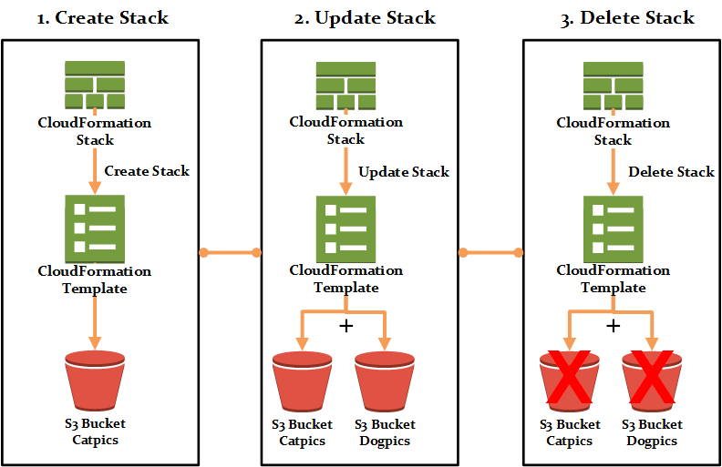

*Figure 7-02: CloudFormation Lab Sections*

Before starting the lab, you must first understand the CloudFormation templates. The templates are pieces of code. This CloudFormation is used to create or update a stack. Let us consider a template as code. It is a way of specifying resources declaratively, and it is written in either the JSON or the YAML format.

1. Download template files from the GitHub Repository provided in the link below:

https://github.com/12920/IPSLabResources/blob/main/Course-Certified-Solutions-Architect-Associate tree/master/labs/getting_started_with_cfn

1. After downloading the templates file, open **templatesstructure.json** in the code editor.
2. This is a CloudFormation template, and it has nine sections. Not all of these sections are required. This is an example of a template written in JSON.

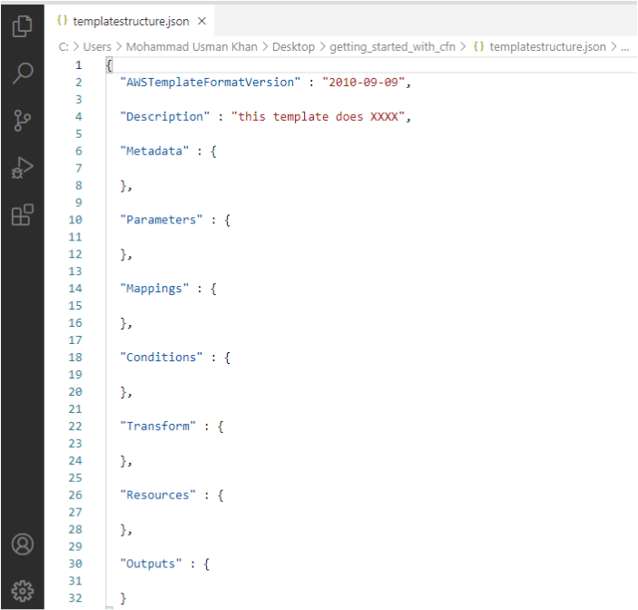

1. There is an equivalent YAML version at template structure.yaml.

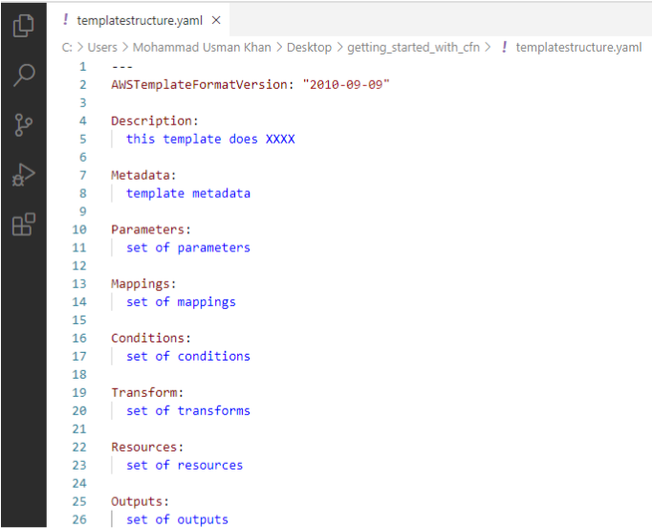

1. Note that the patterns are the same. Both files contain nine sections.
2. In this lab, a JSON format template is used.
3. The first section of a CloudFormation template is the **format** version. This is optional. However, if the template format changes, it is difficult to future-proof the product.

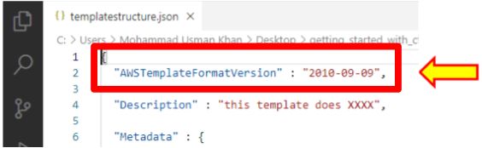

1. The next section is **Description**. This is where you can describe the template.

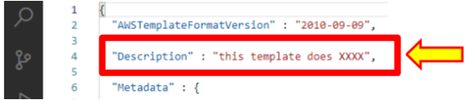

1. The **metadata** section is a multi-purpose section. It can be used for something simple, like controlling how the template looks when creating a stack.

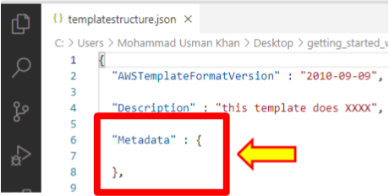

1. The **parameter** section is where you can define the information that you want the template to ask for.

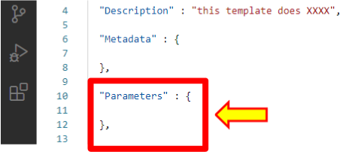

1. The next section is **Mappings**, which allows you to include data that can be used conditionally.

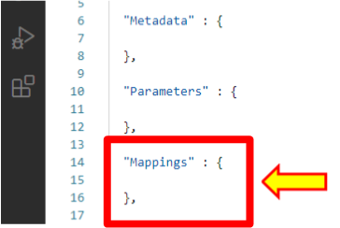

1. The **Conditions** section controls whether specific resource properties are assigned based on several values.

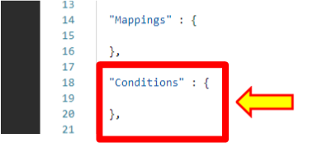

1. The transformation section is something that is usually used for serverless applications.

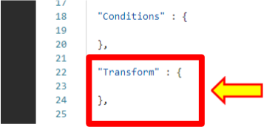

1. The **outputs** are another optional part of the template that allows you to return values once the stack is completed.

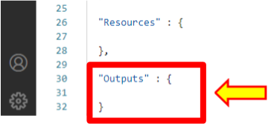

1. Now, the **resources** section is the last part of a CloudFormation template. It is a very important part of the CloudFormation template.

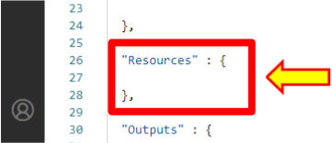

1. The template that is used in this lab is **createstack.json**. This template only has a resource section used; all of the other sections are optional.

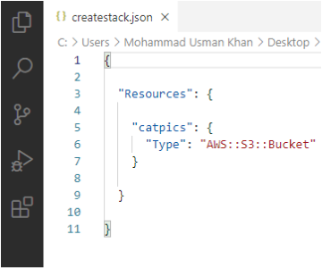

**Follow the given steps to create the AWS CloudFormation stack.**

1. Log in to the AWS Console.
2. Click on **Services**.
3. Scroll down to **Management & Governance**. Select **CloudFormation**.

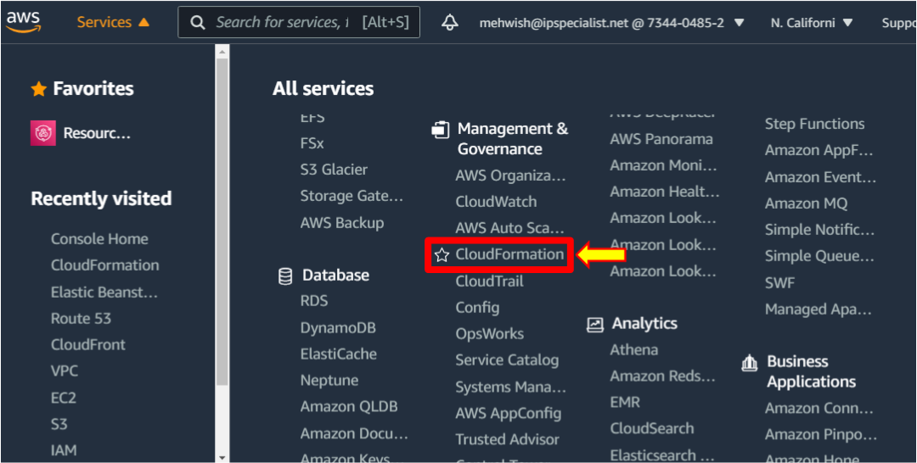

**Create a CloudFormation Stack**

1. If you have never used CloudFormation, you will get a screen like the following.

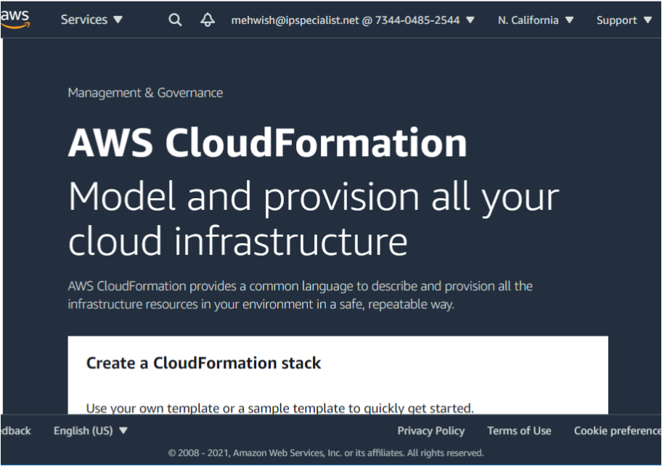

1. Click on the **Create stack** button.

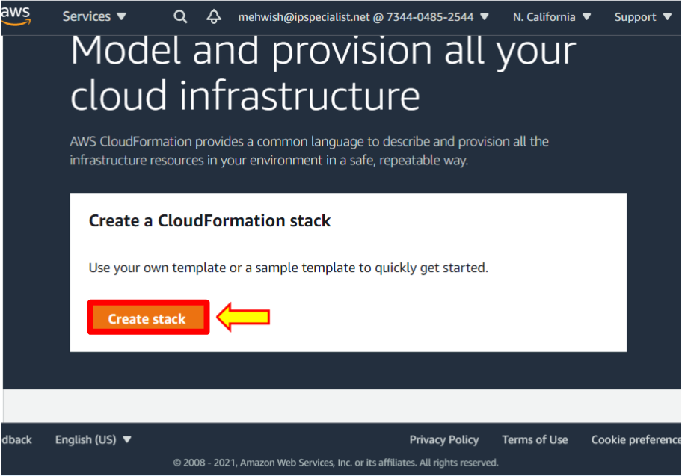

1. Select **Template is ready**.

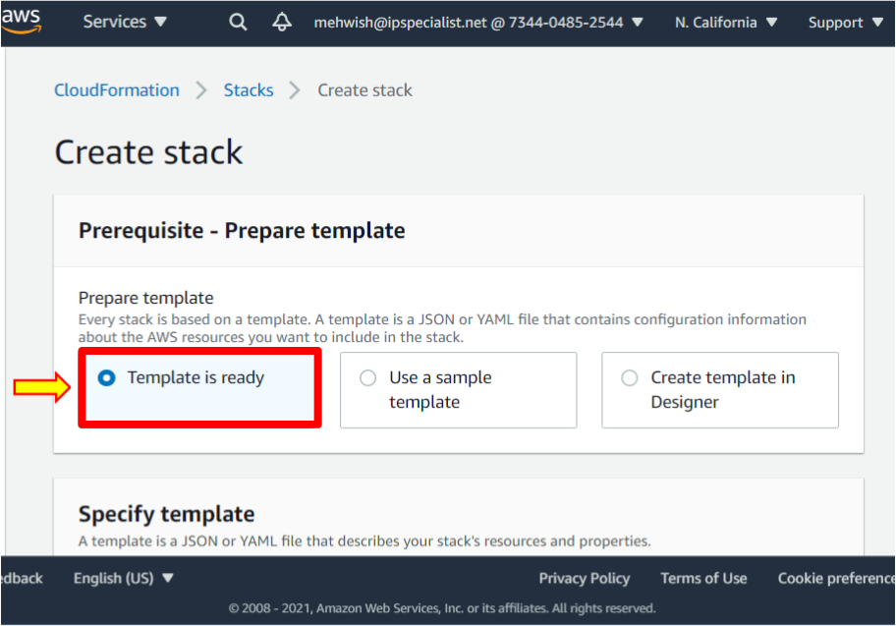

1. Select **Upload a template file**.

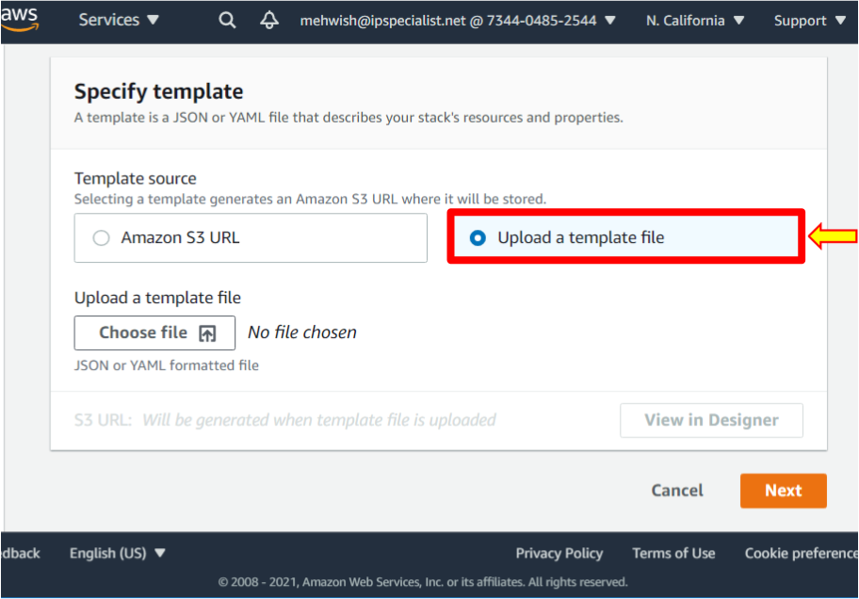

1. Click on the **Choose file** button.

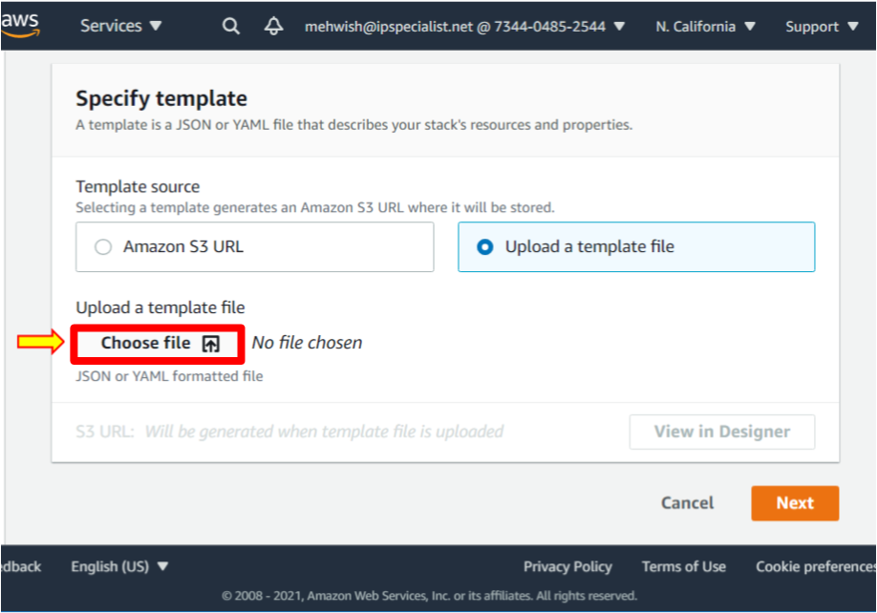

1. Select the file **createstack.json** and click **Open** to upload it.

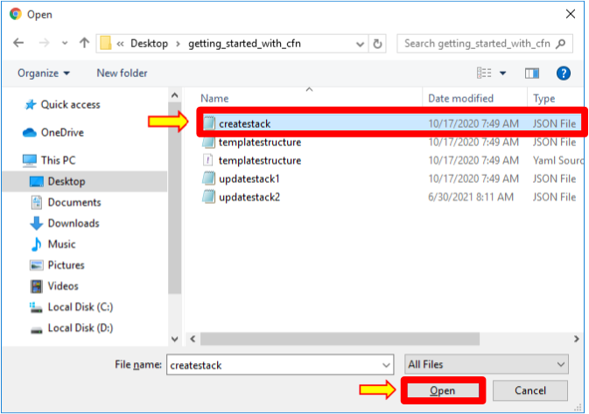

1. Then click on the **Next** button.

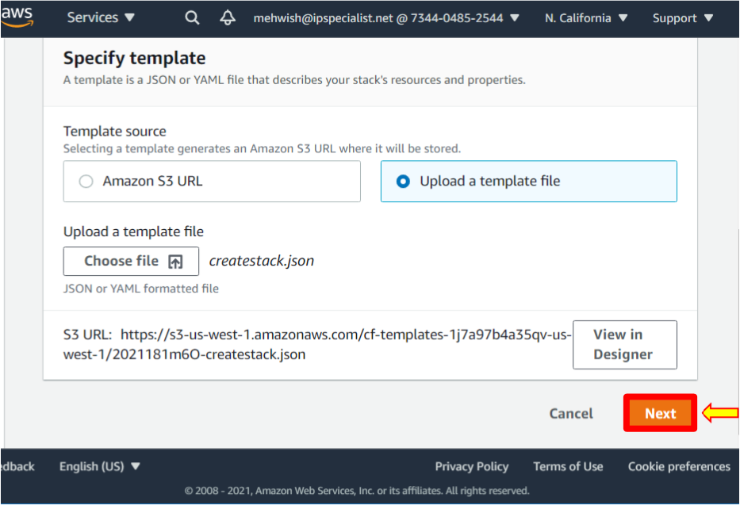

1. Name the stack **IPS-cfnlab**.

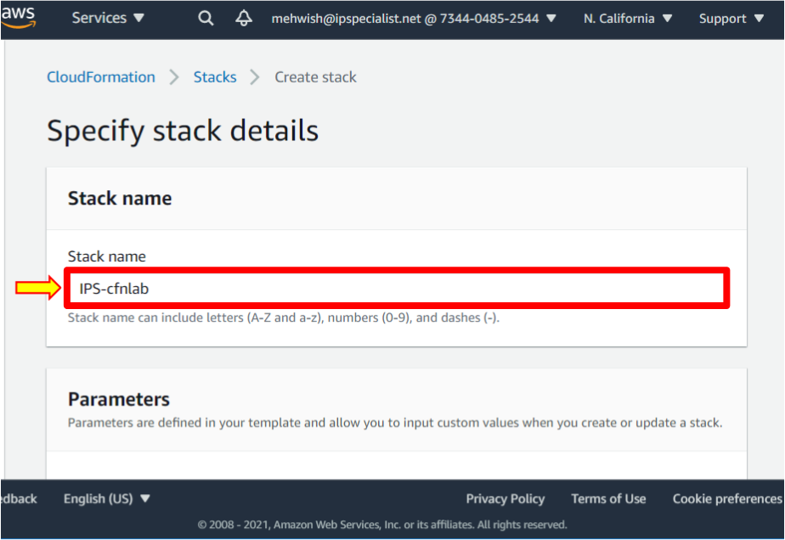

1. Click **Next**.

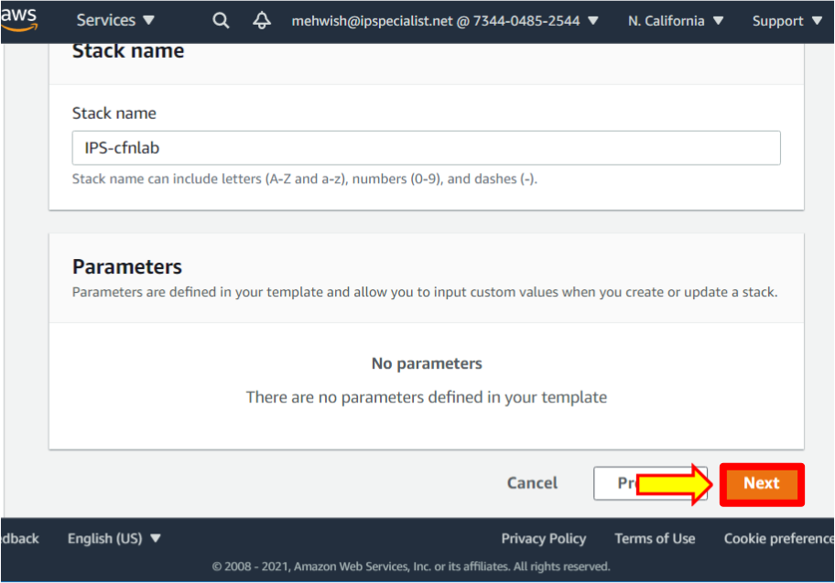

1. Leave everything as default and scroll down. Click **Next**.

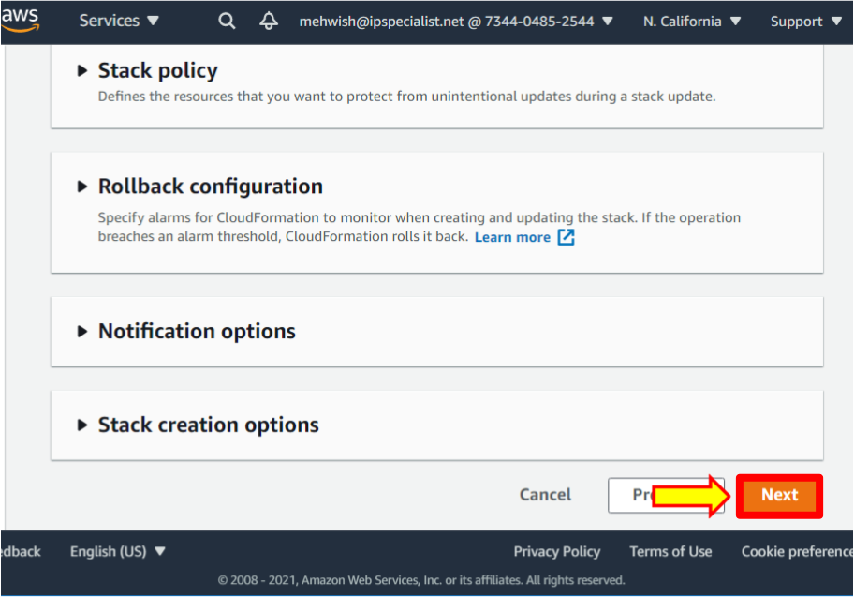

1. Review the stack and scroll down, leaving everything as default. Then click on the **Create stack** button.

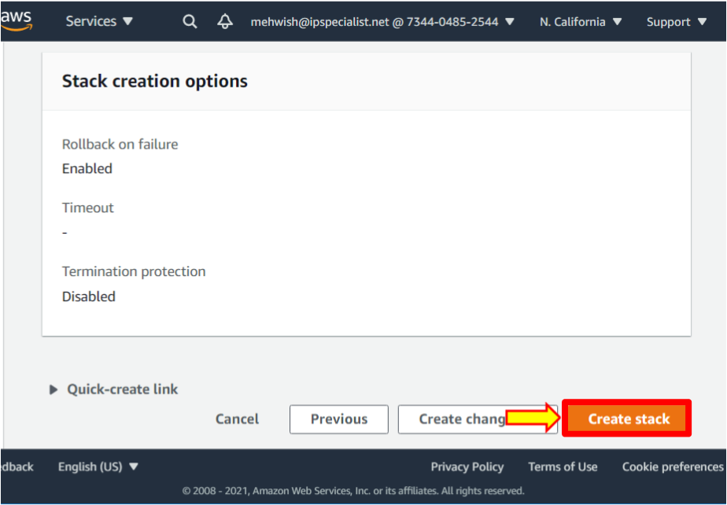

1. Refresh the page by clicking on the refresh button to watch the progress.

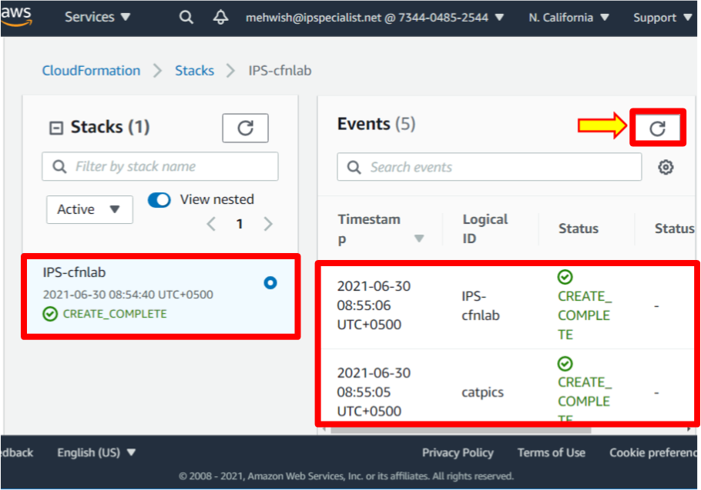

1. Now go to **S3**. As we did not specify the name in the **.json** file for this bucket, AWS names it with the **<STACK_NAME>-<LOGICAL_VOLUME_NAME>-<RANDOM_STRING>** format. In this case will be: **ips-cfnlab-catpics-<RANDOM_STRING>**.

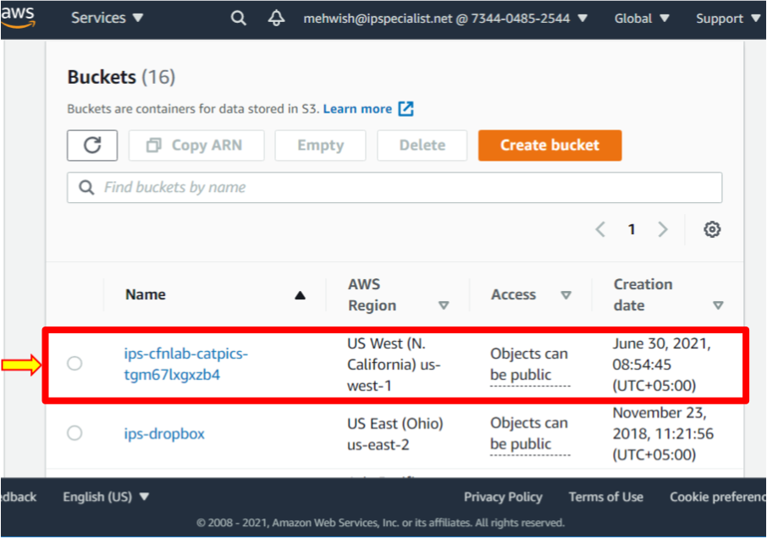

Update the CloudFormation Stack

Update # 1

1. Go to the CloudFormation dashboard by clicking on **Stacks**.

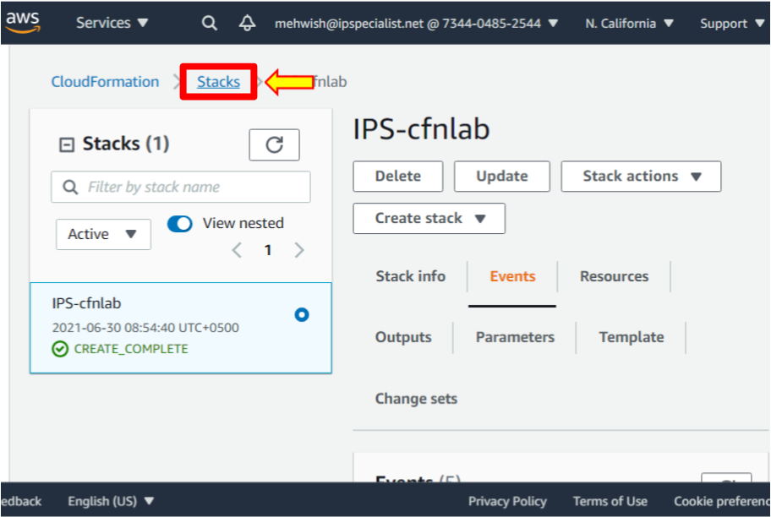

1. Select the **IPS-cfnlab** stack. Then click on the **Update** button.

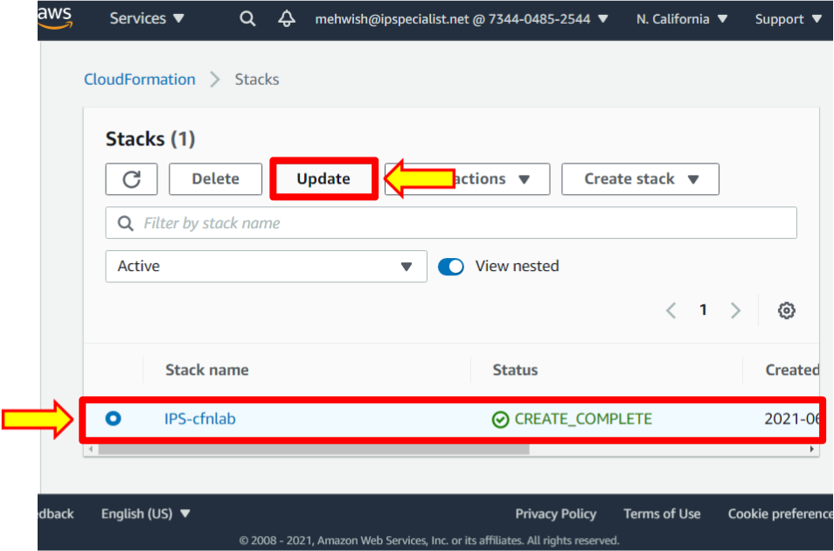

1. Select **Replace current template**.

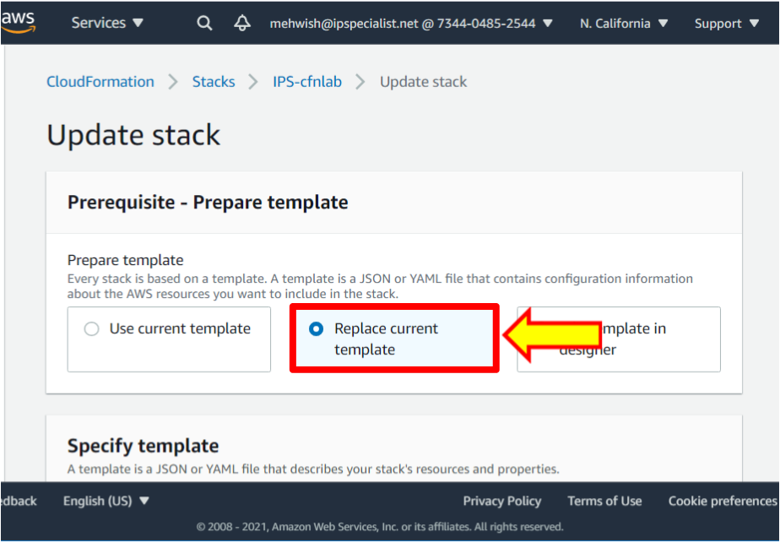

1. Then select **Upload a template file**.

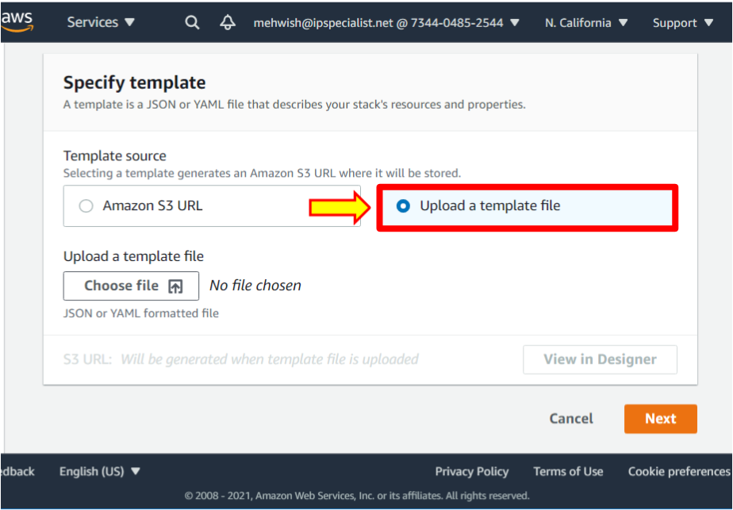

1. Click **Choose file**.

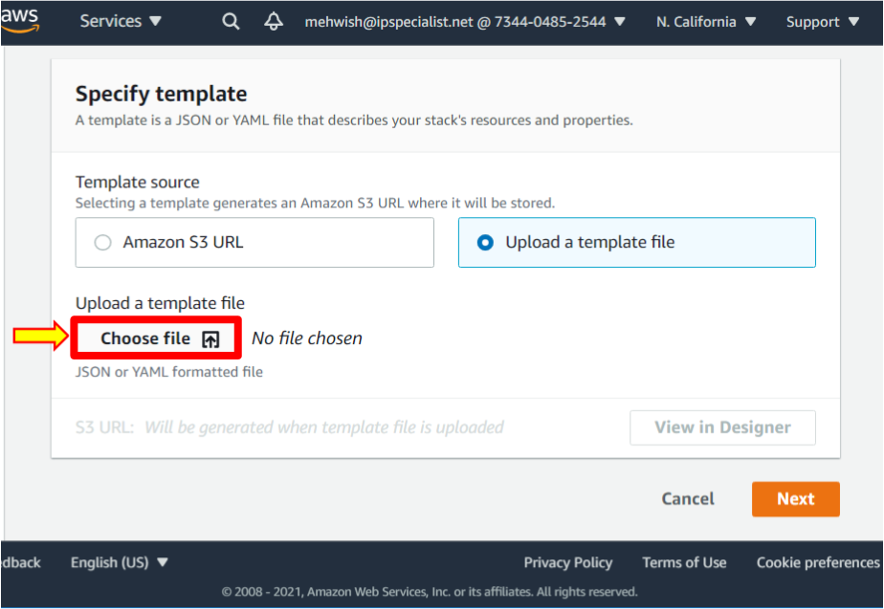

1. Select the file **updatestack1.json**. Then click **Open** to upload it.

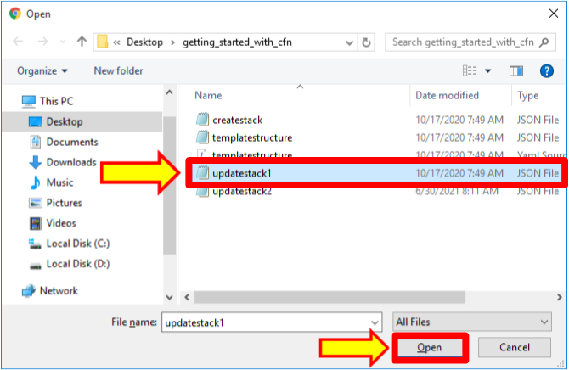

1. Click **Next**.

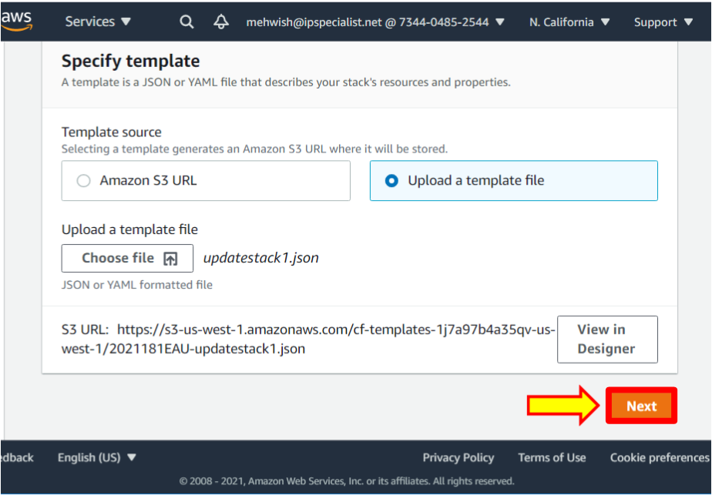

1. Again, click **Next**.

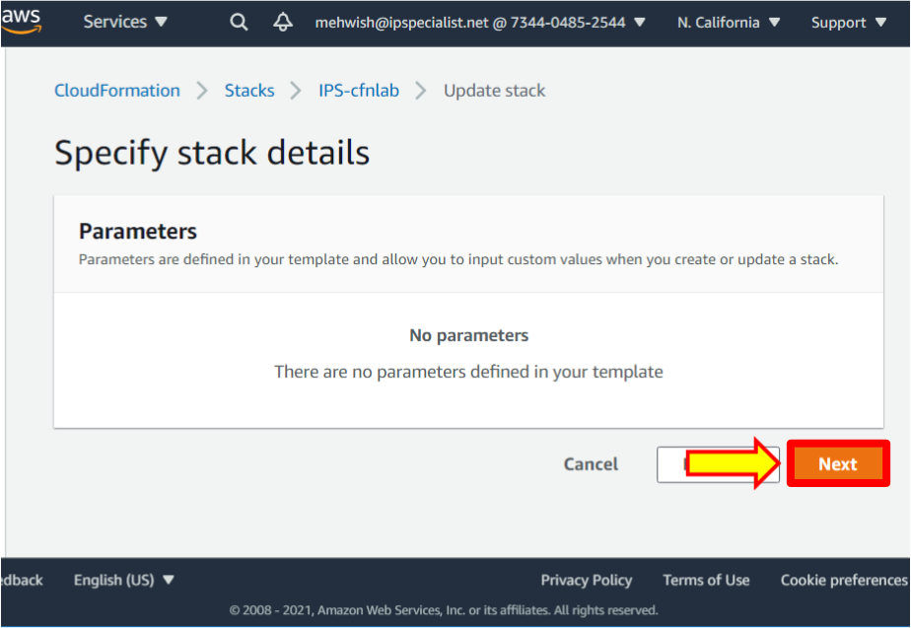

1. Leave everything as default in **Configure stack options**. Scroll down and click on the **Next** button.

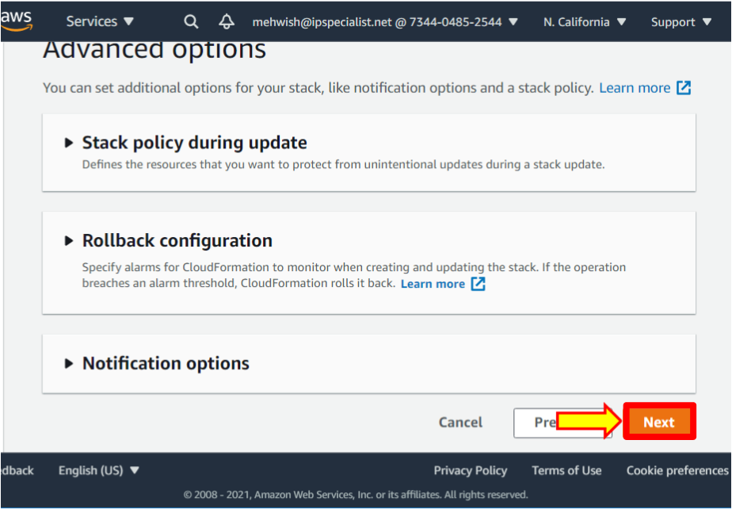

1. Review the stack and scroll down, leaving everything as default. Scroll down to see the changes. Click on the **Update stack** button.

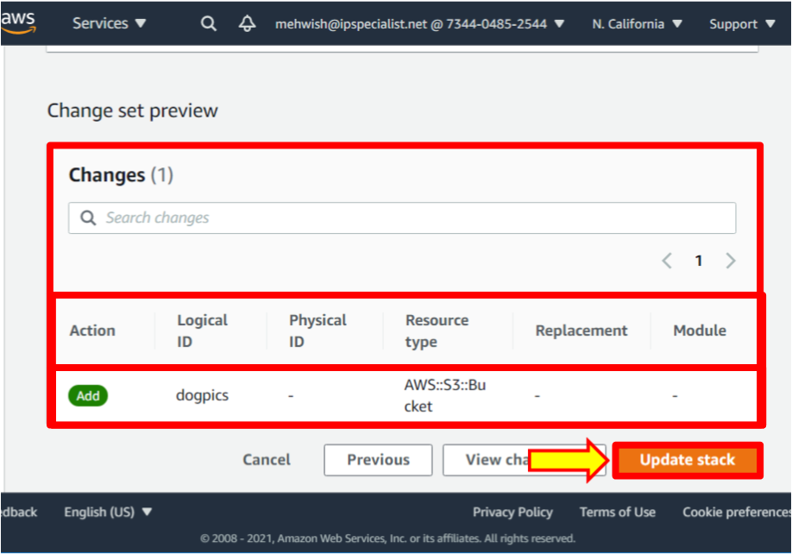

1. Refresh the page by clicking on the refresh button to watch the progress.

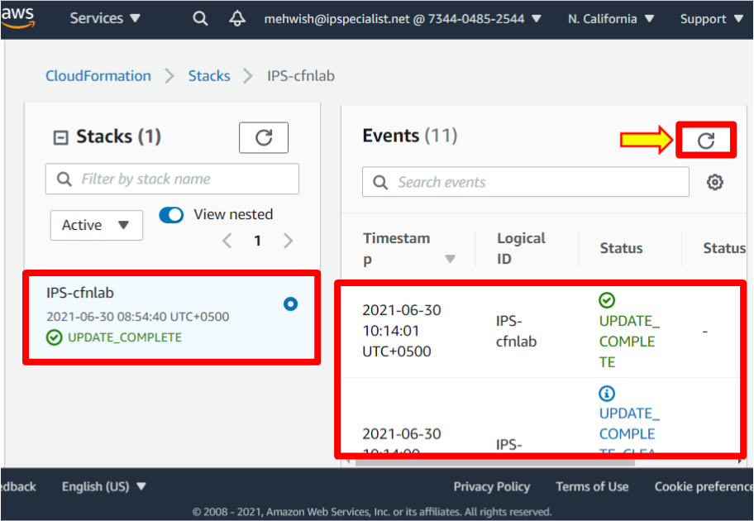

1. Once it has finished updating, go to **S3**. You should see the new **dogpics** bucket.

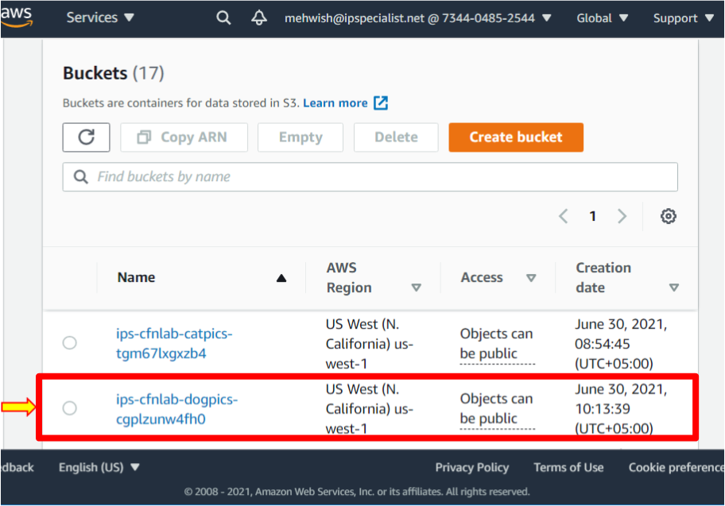

**Remove the Update**

1. Go back to the CloudFormation dashboard by clicking on **Stacks**.

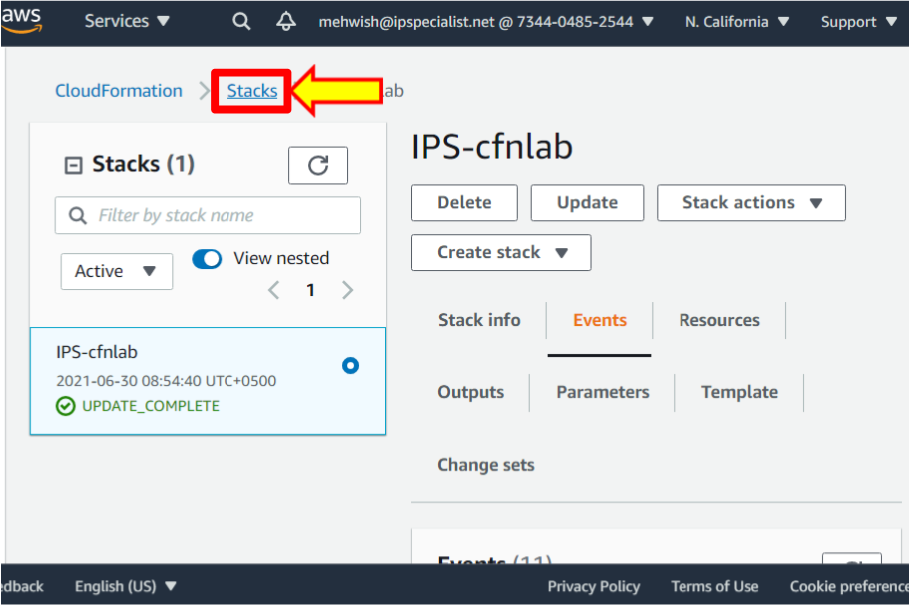

1. Select the **IPS-cfnlab** stack. Then click on the **Update** button.

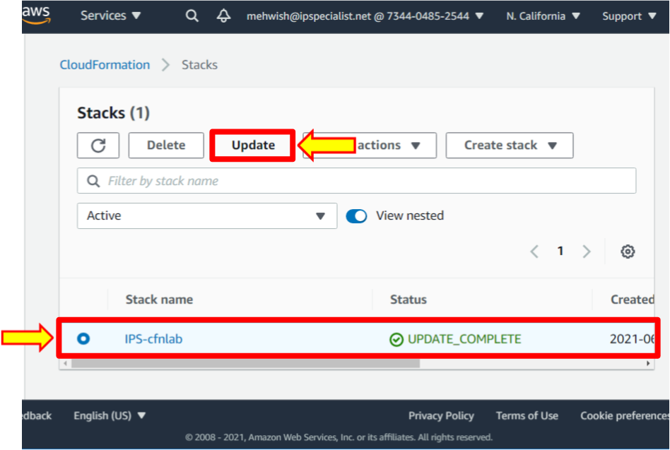

1. Select **Replace current template**.

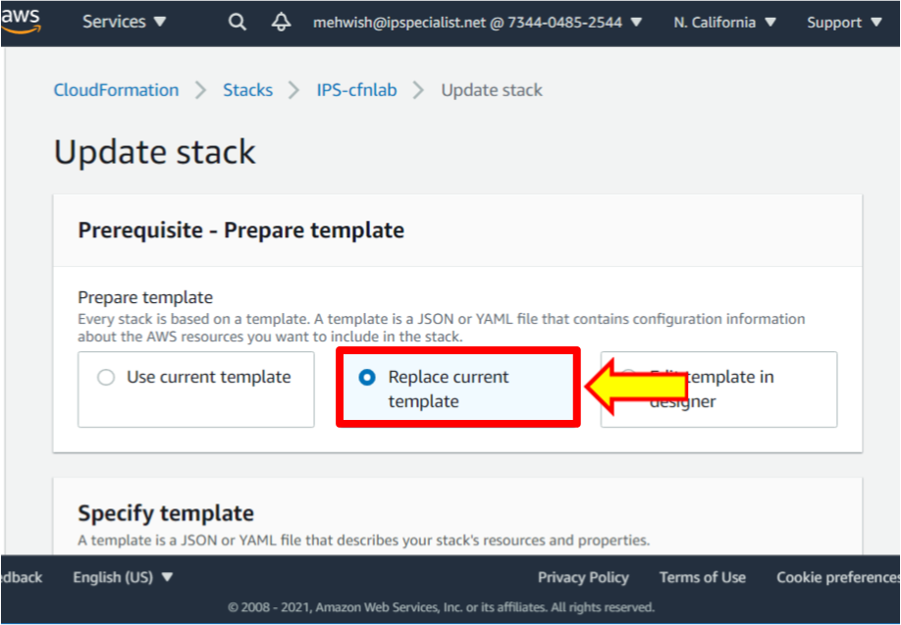

1. Select **Upload a template file**.

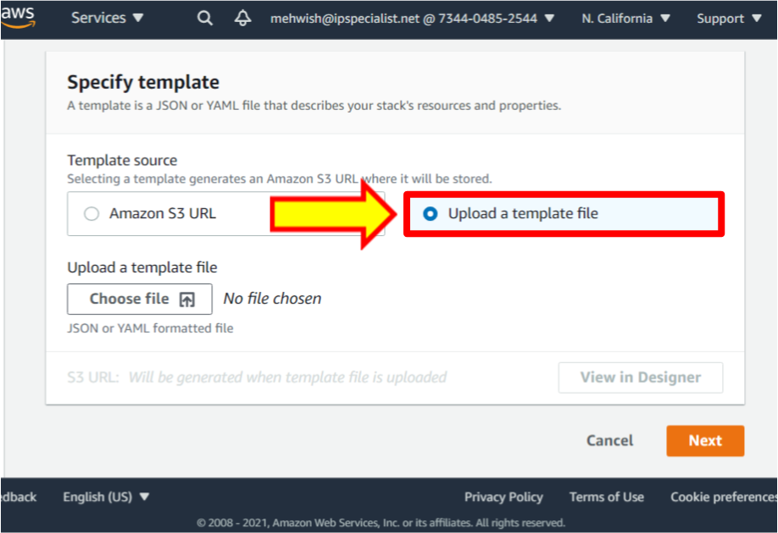

1. Click **Choose file**.

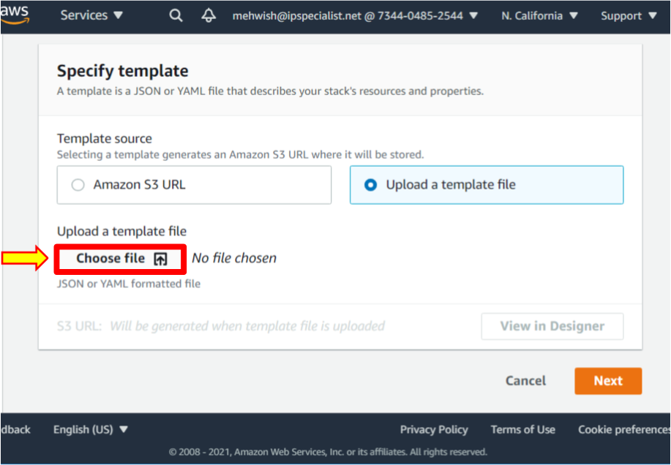

1. Select the file **createstack.json** again. Then click **Open** to upload it.

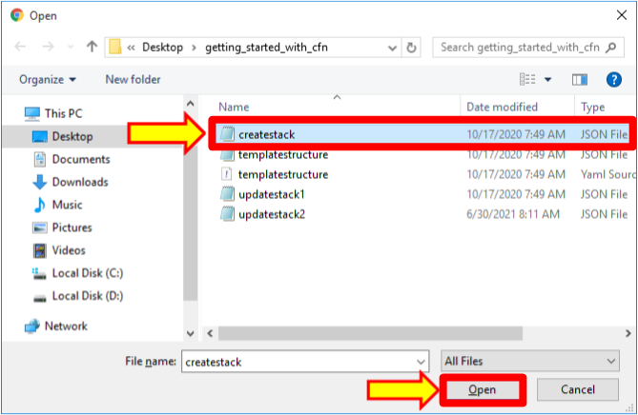

1. Click **Next**.

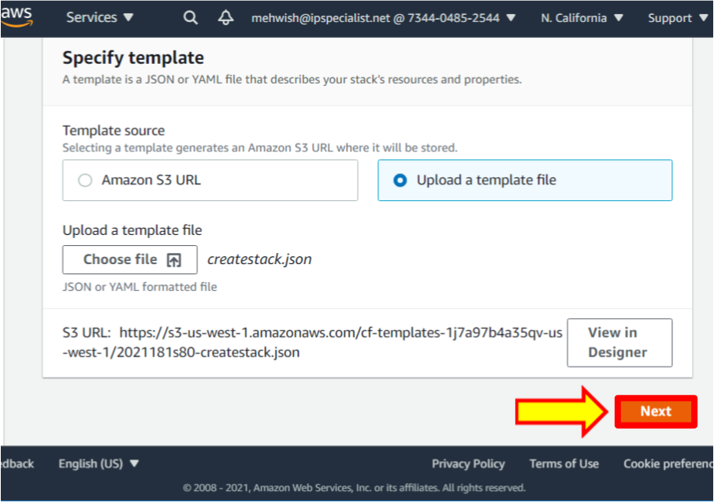

1. Again, click **Next**.

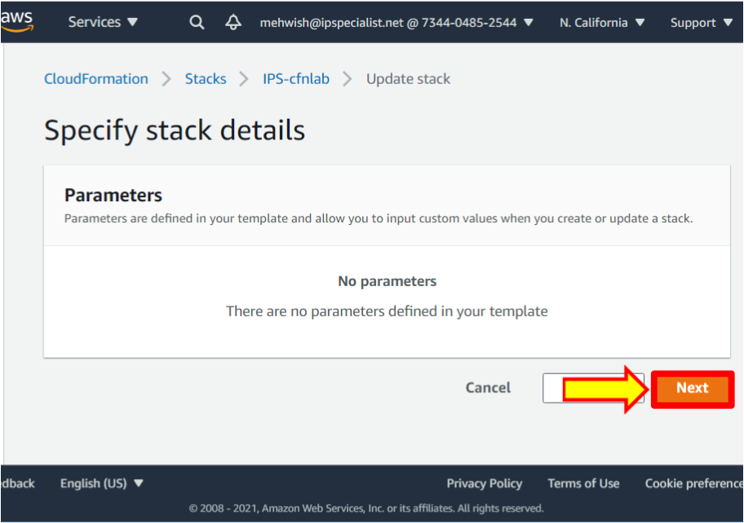

1. Leave everything as default in **Configure stack options**. Scroll down and click **Next**.

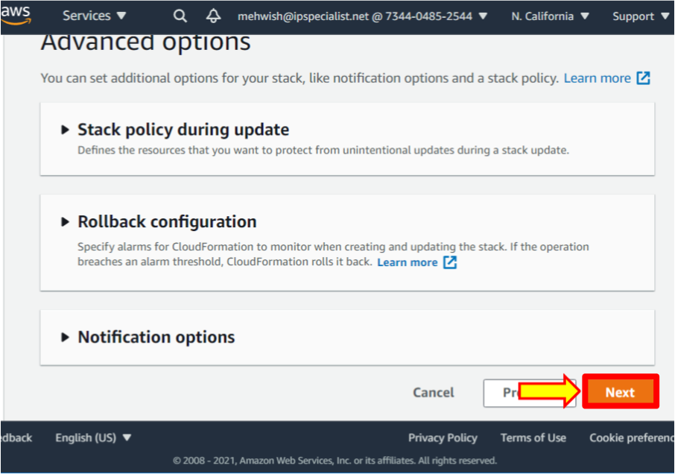

1. Review the stack and scroll down, leaving everything as default. Scroll down, and you will see the changes. Click on the **Update stack** button.

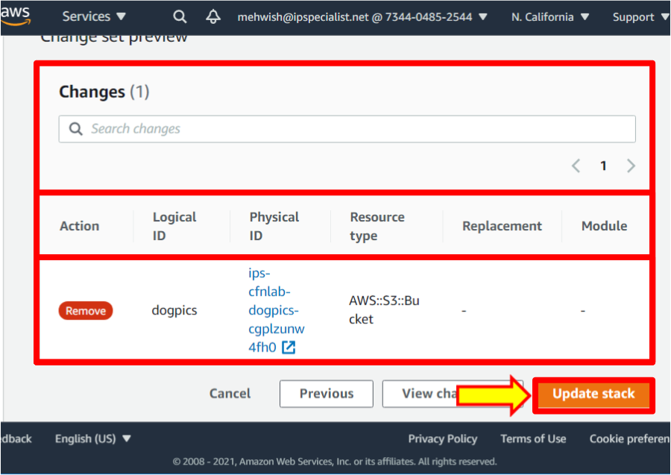

1. Refresh the page by clicking on the refresh button to watch the progress.

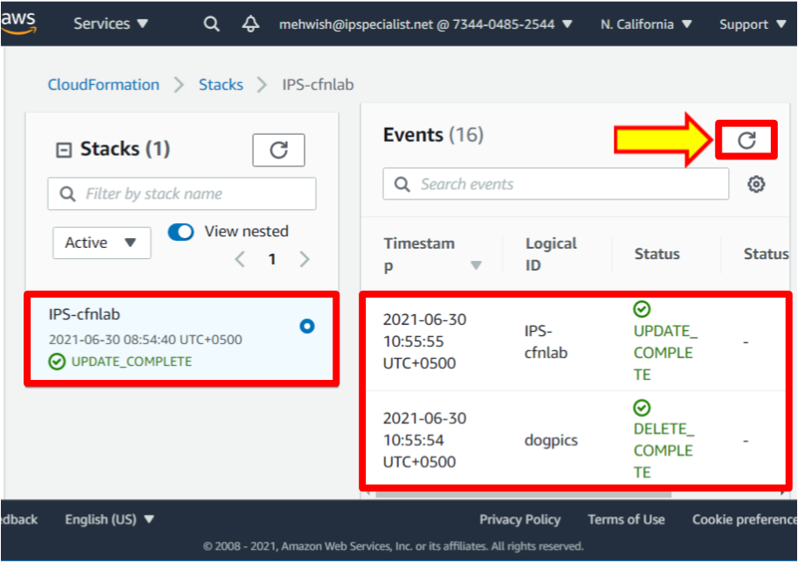

1. Once it has finished updating, navigate to **S3**. You should see the **dogpics** bucket is now gone.

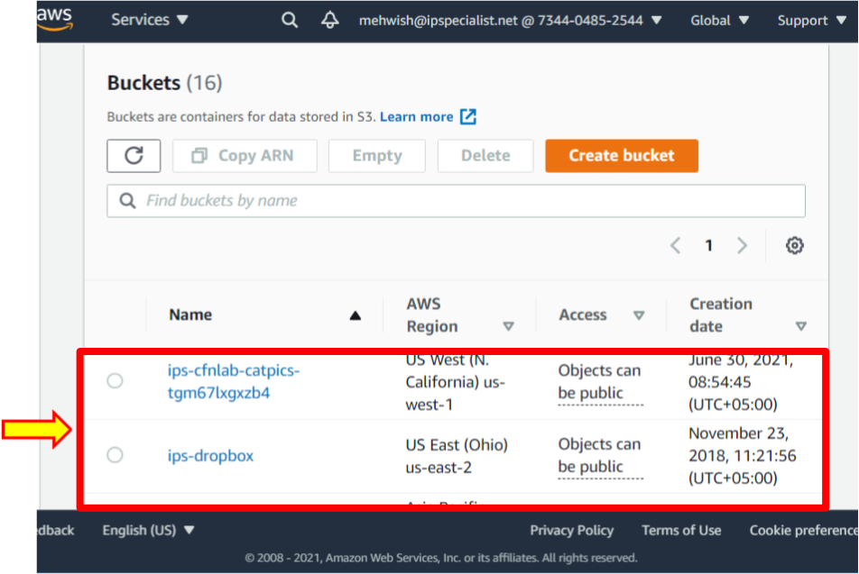

Update # 2

1. Open the **updatestack2.json** file in the code editor.

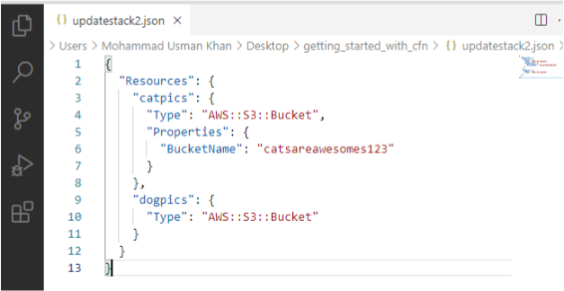

1. Change 123 characters in **catsareawesome123** to something unique: e.g., your birthday and today's date.

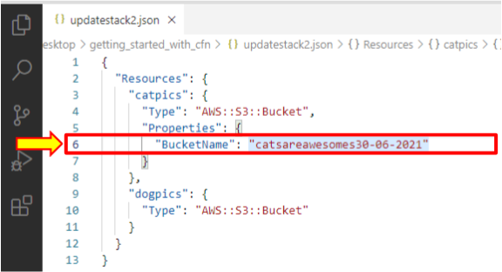

1. **Save** the file.

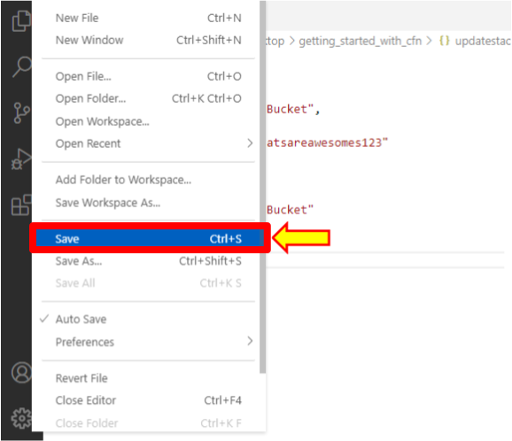

1. Now, go back into the CloudFormation dashboard by clicking on **Stacks**.

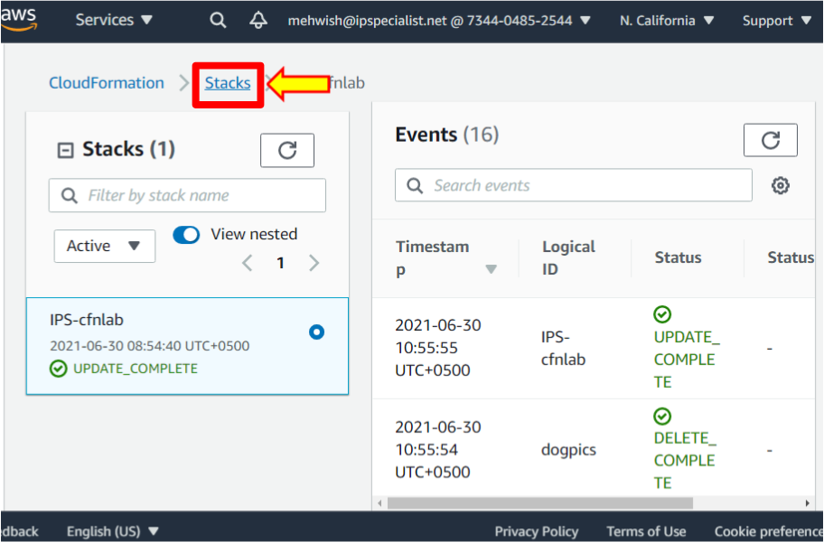

1. Select the **IPS-cfnlab** stack. Then click on the **Update** button.

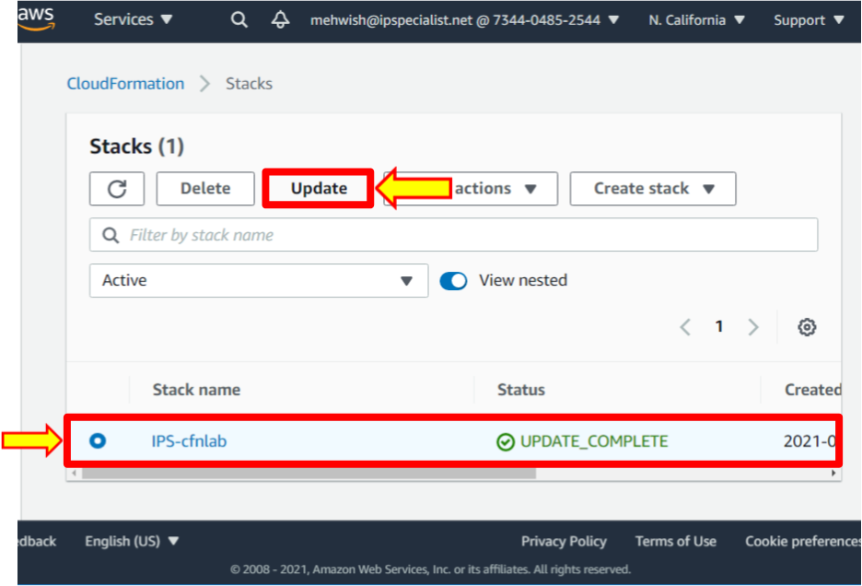

1. Select **Replace current template**.

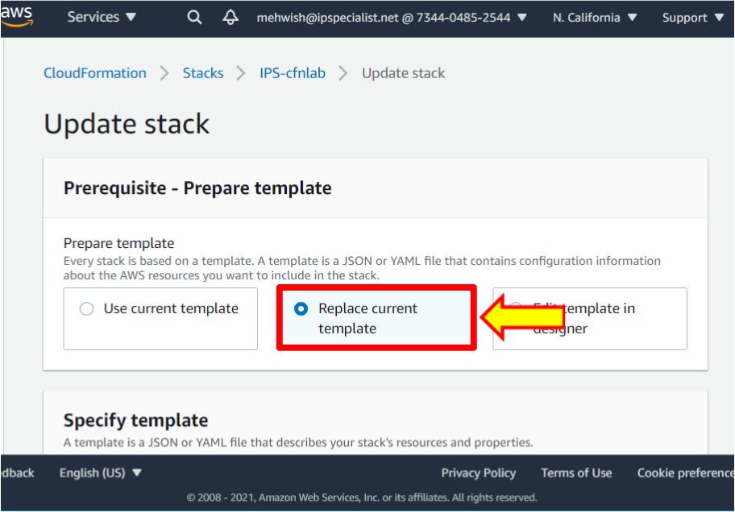

1. Then select **Upload a template file**.

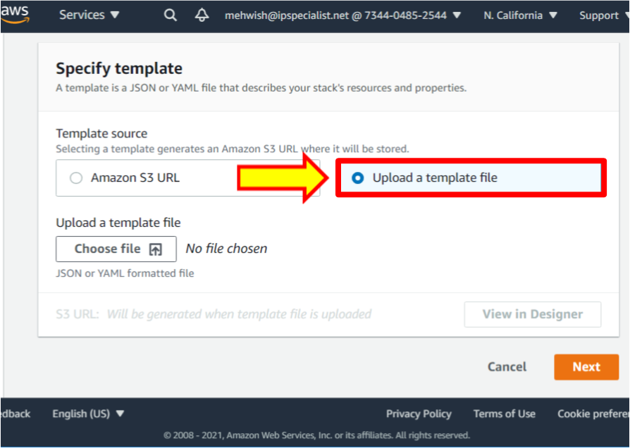

1. Click on **Choose file**.

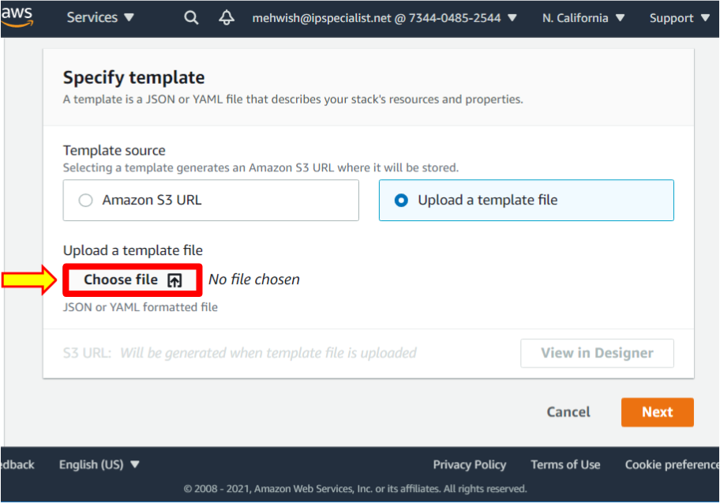

1. Select the file **updatestack2.json**. Then click **Open** to upload it.

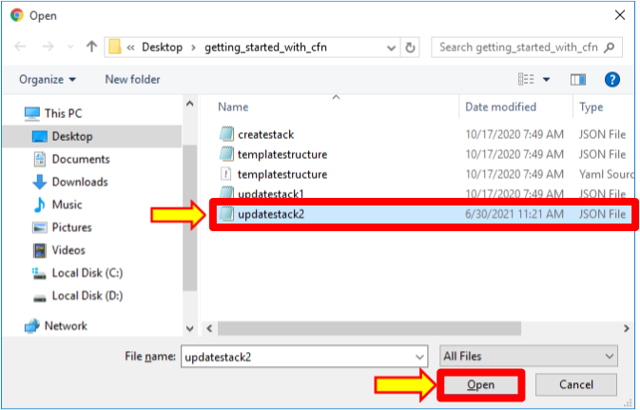

1. Click **Next**.

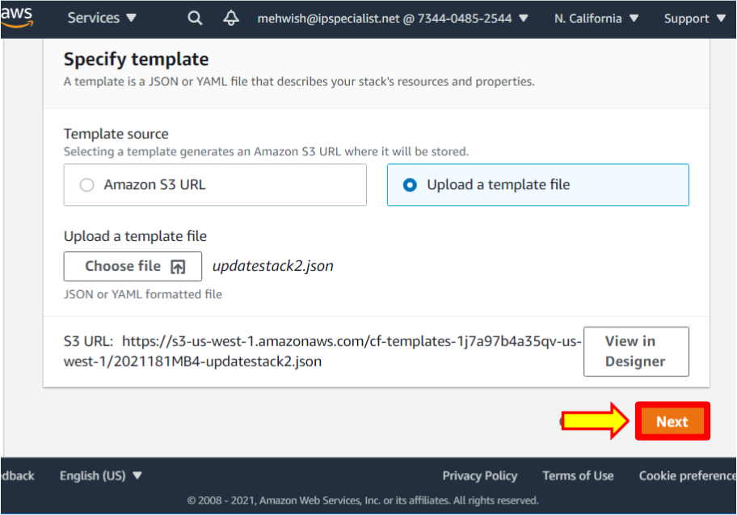

1. Again, click **Next**.

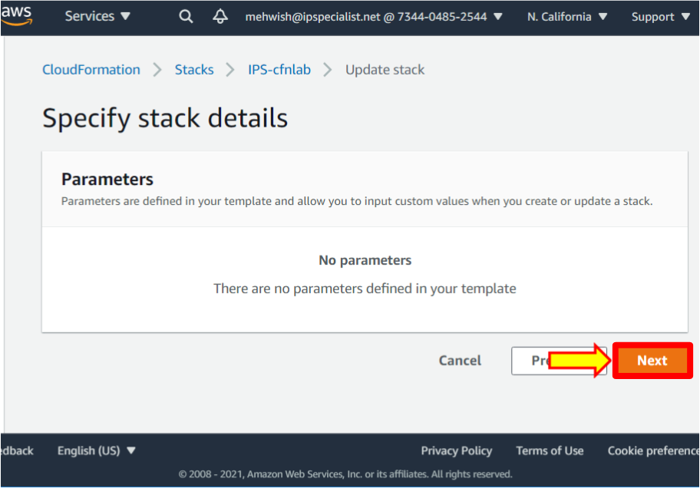

1. Leave everything as default in configure stack options. Scroll down and click **Next**.

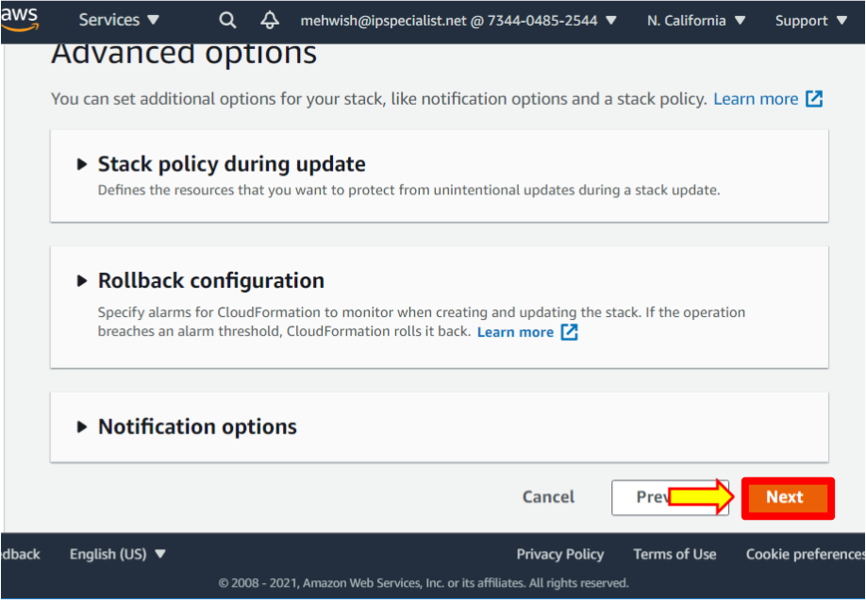

1. Review the stack and scroll down, leaving everything as default. Scroll down, and you will see the changes. Click on the **Update stack** button.

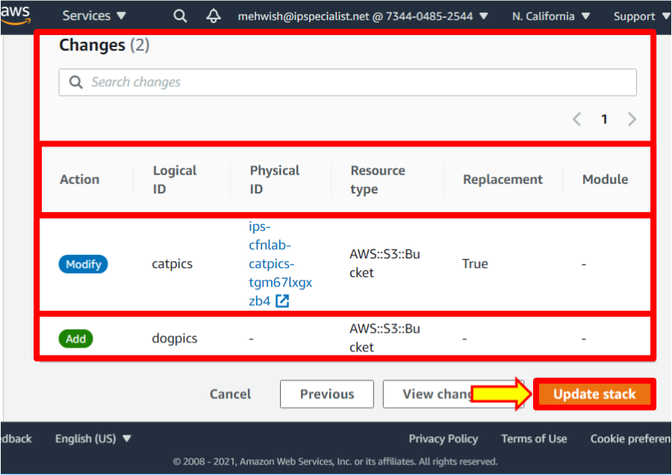

1. Refresh the page by clicking on the refresh button to watch the progress.

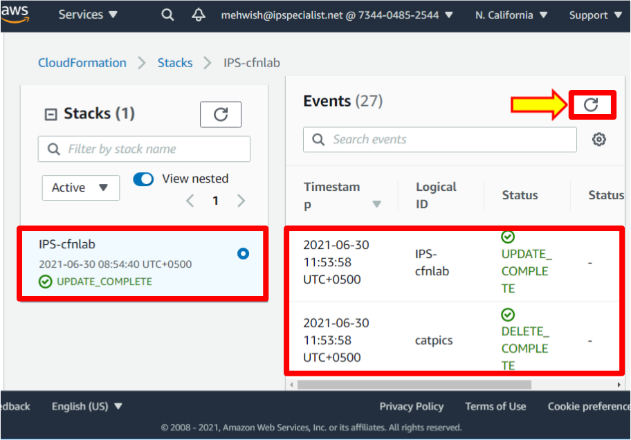

1. Once it has finished updating, go to **S3**. You should see two changes: the **dogpics** bucket is back, and the bucket name is updated to the new value.

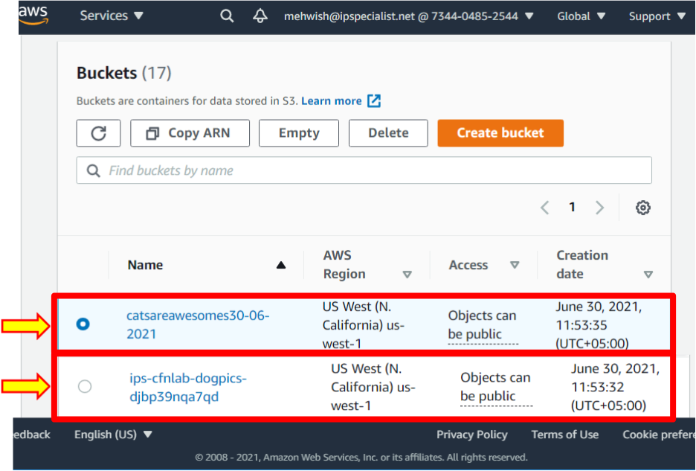

Add CloudFormation Stacks

1. Now, create a new stack with **updatestack2.json**.
2. Go to the CloudFormation dashboard by clicking on **Stacks**.

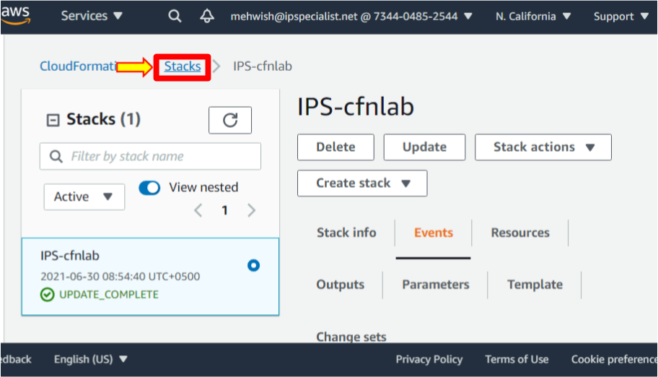

1. Click **Create stack** > **With new resources (standard)**.

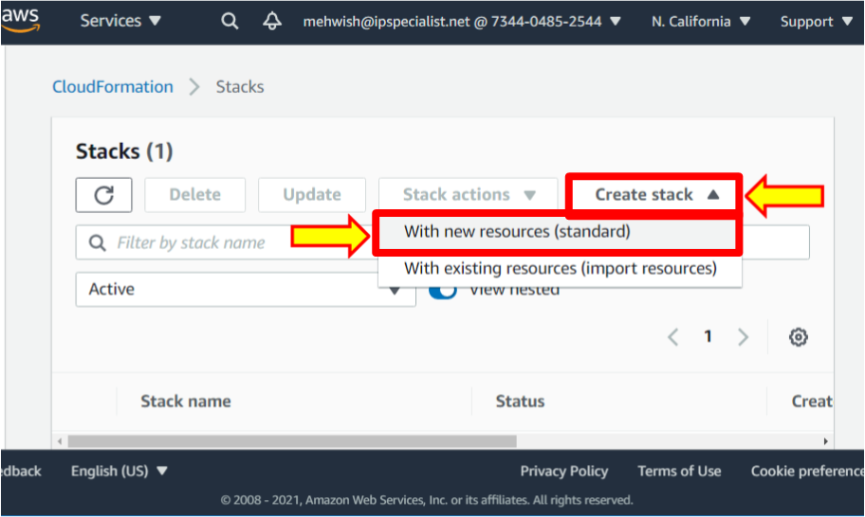

1. Select **Template is ready**.

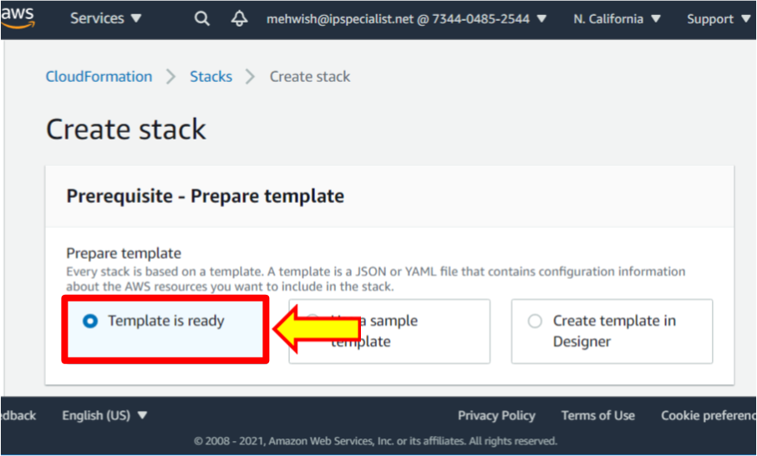

1. Then, select **Upload a template** **file**.

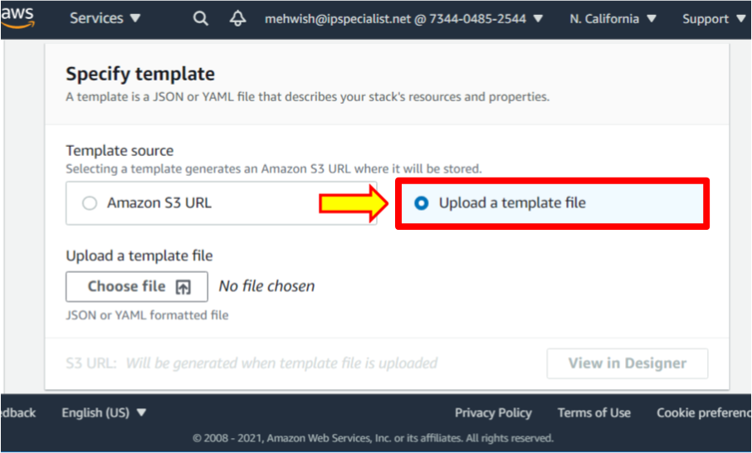

1. Click **Choose file**.

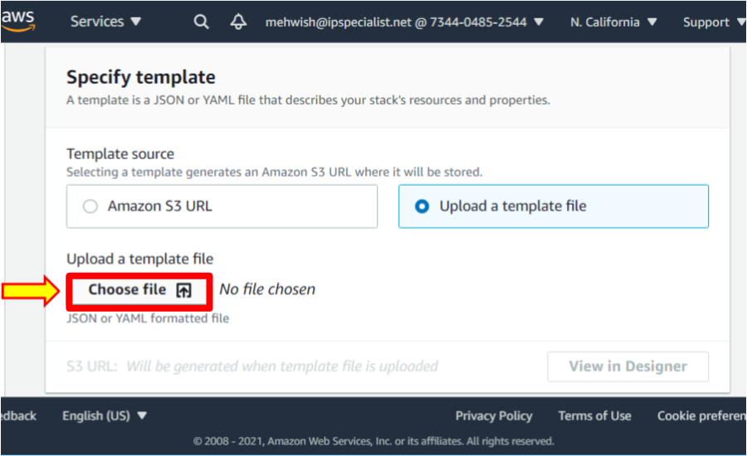

1. Select and upload the **updatestack2.json** file.

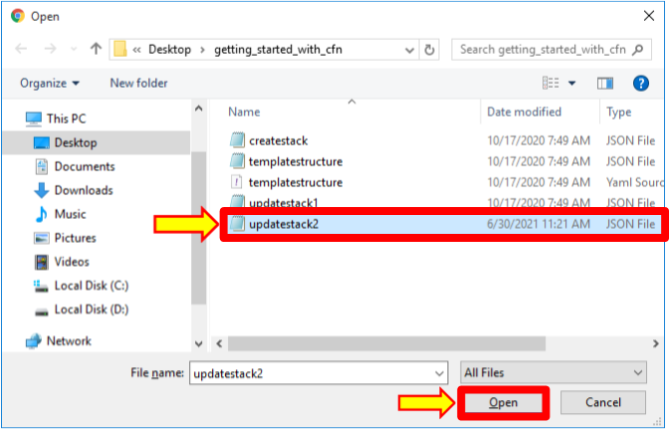

1. Click **Next**.

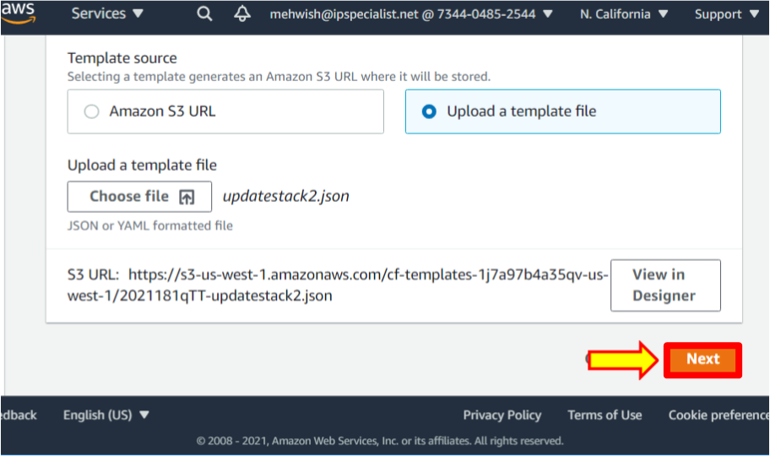

1. Name the stack **IPS-cfnlab2**. Then click **Next**.

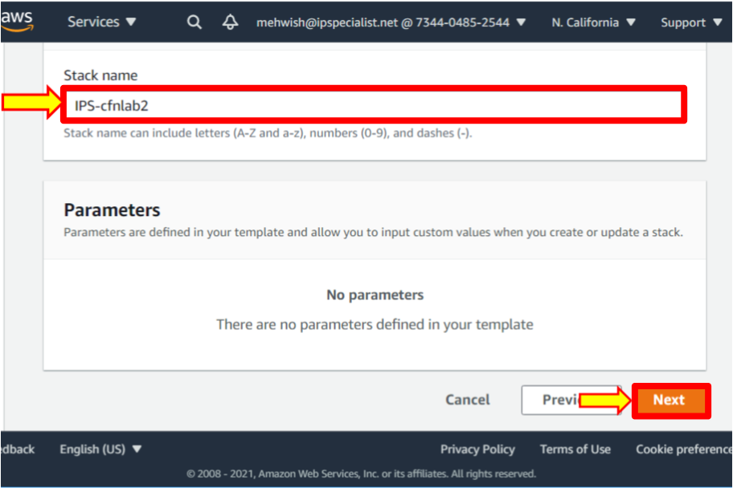

1. Leave everything as default in **Configure stack options**. Scroll down and click **Next**.

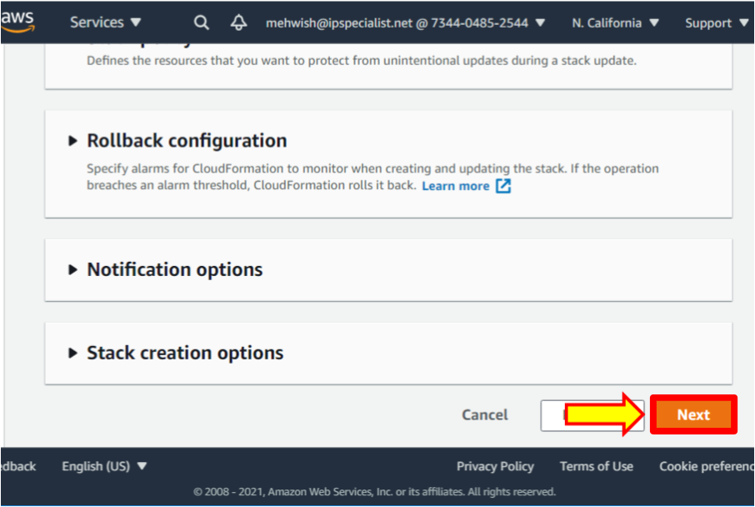

1. Review the stack. Scroll down and click on the **Create stack** button.

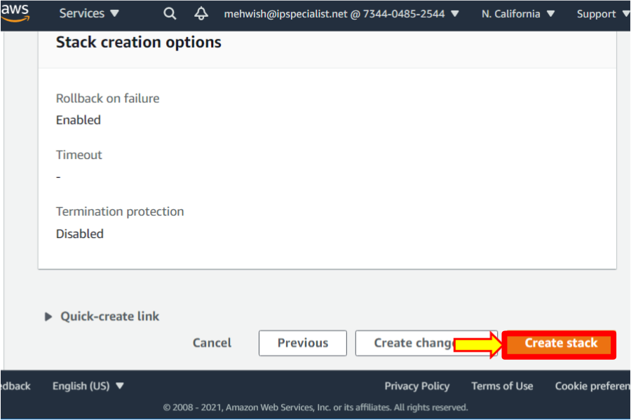

1. Refresh the page to watch the progress.

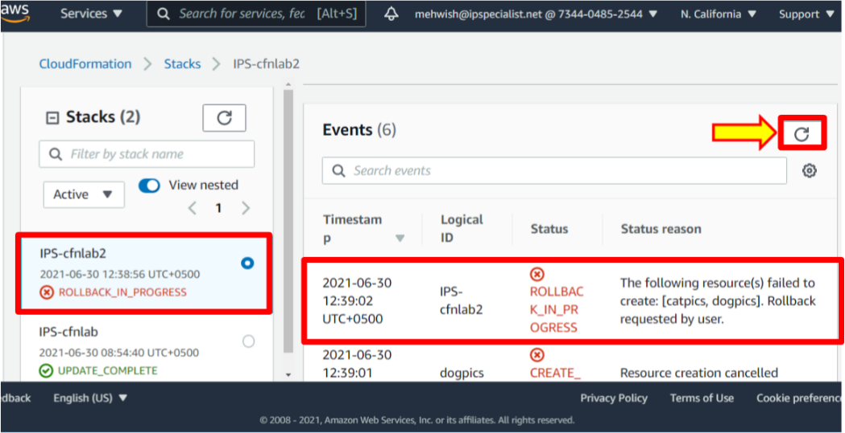

1. Note that the process eventually fails; you cannot have another S3 bucket with the same name.
2. Now, create a stack with **updatestack1.json**.
3. Navigate to the CloudFormation dashboard by clicking on **Stacks**.

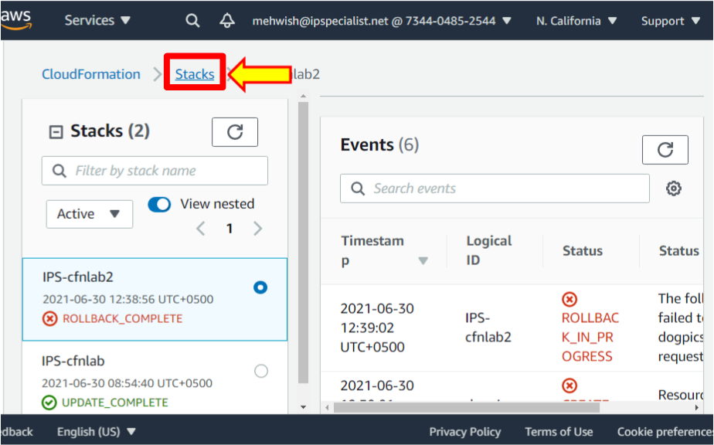

1. Click **Create stack** > **With new resources (standard)**.

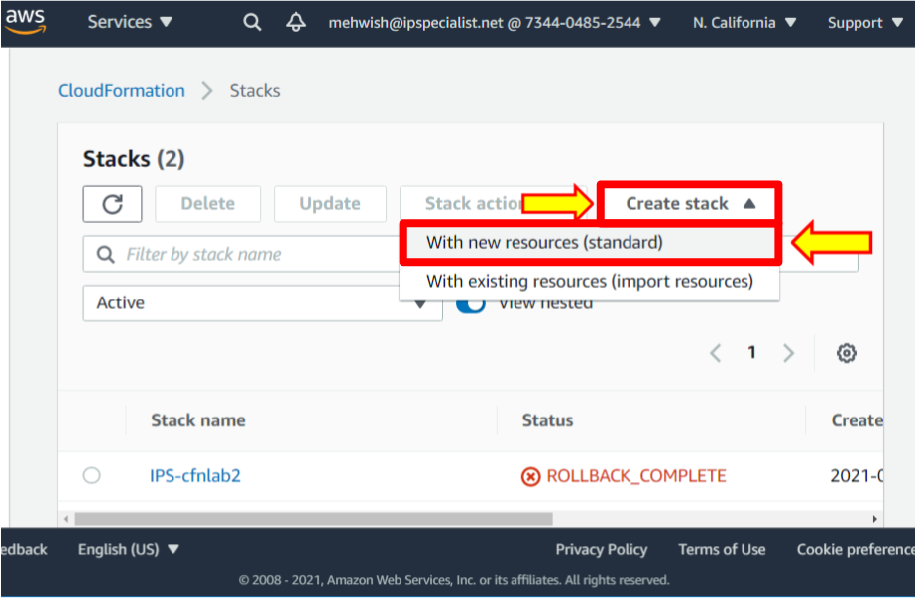

1. Select **Template is ready**.

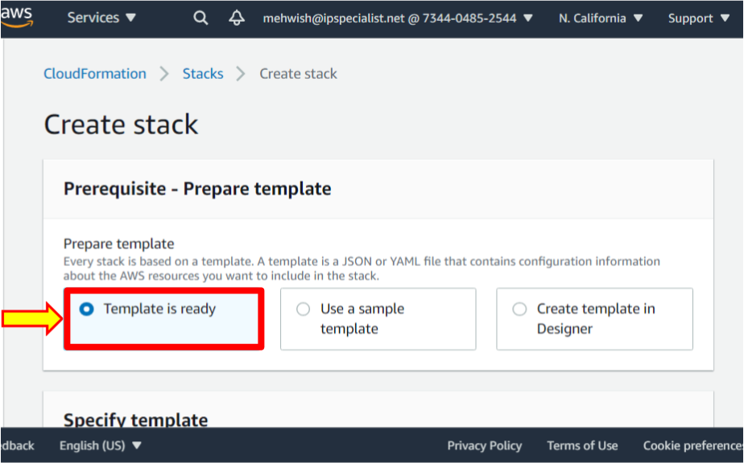

1. Then select **Upload a template** **file**.

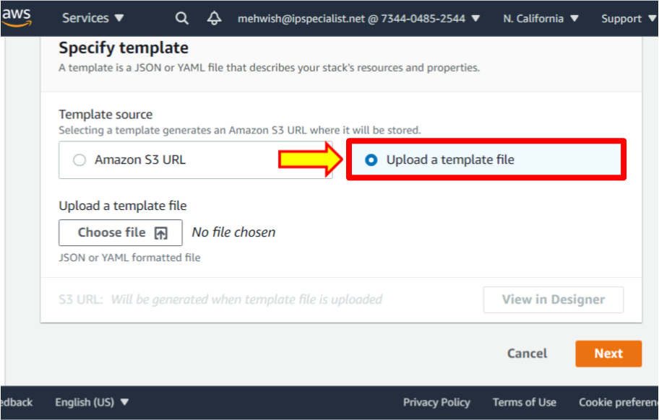

1. Click **Choose file**.

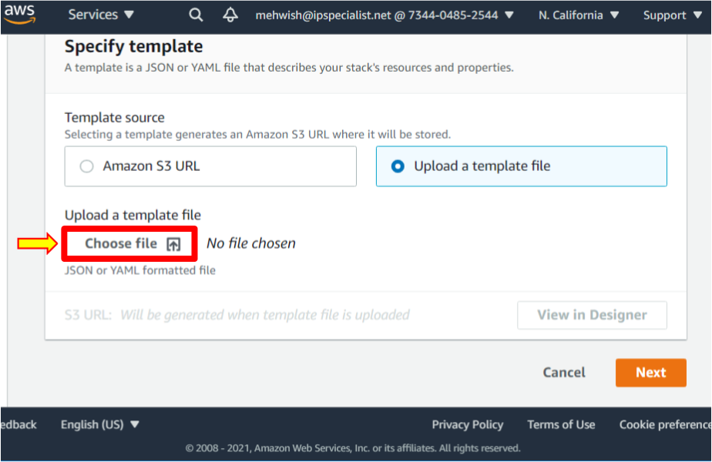

1. Select and upload **updatestack1.json**.

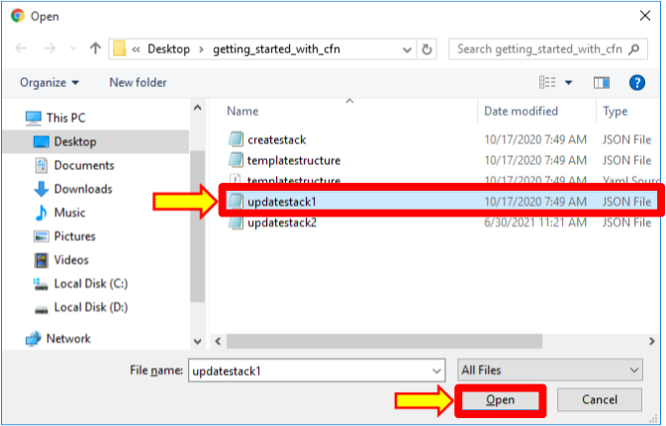

1. Click **Next**.

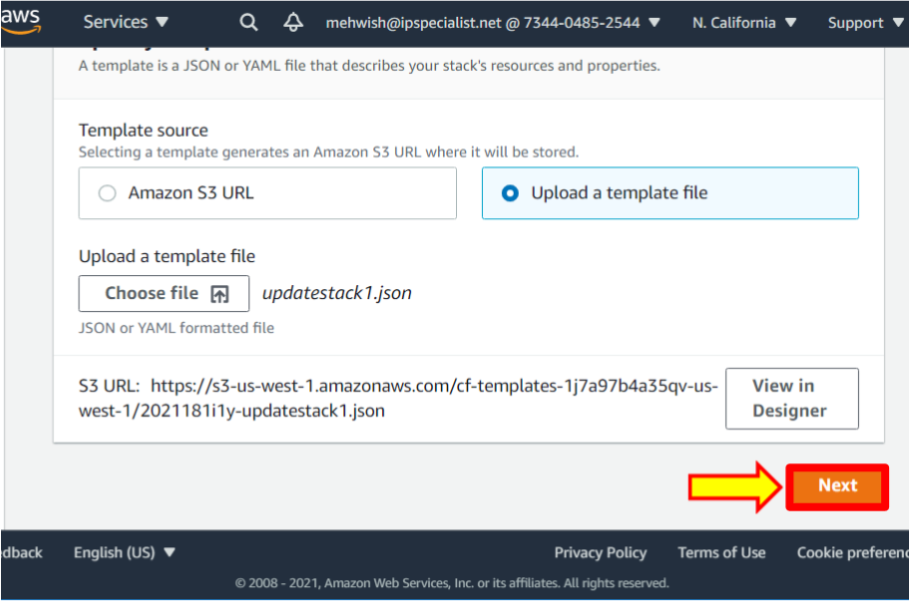

1. Name the stack **IPS-cfnlab3**.

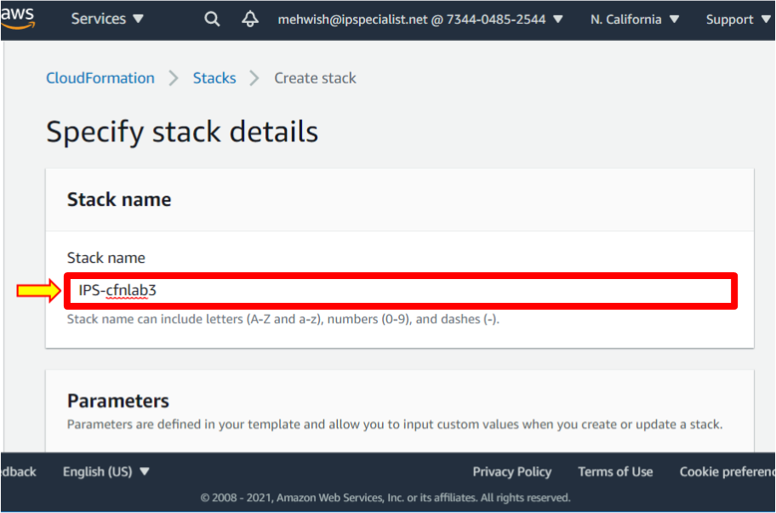

1. Click **Next**.

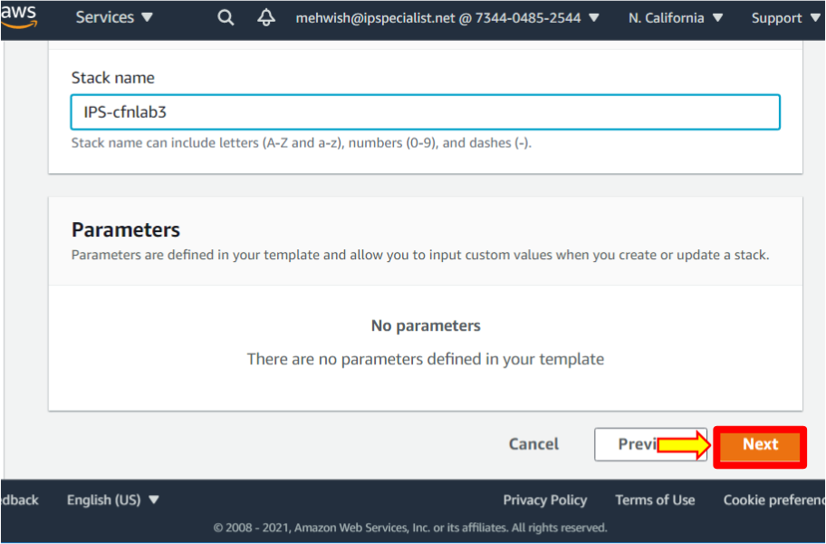

1. Leave everything as default in **Configure stack options**. Scroll down and click **Next**.

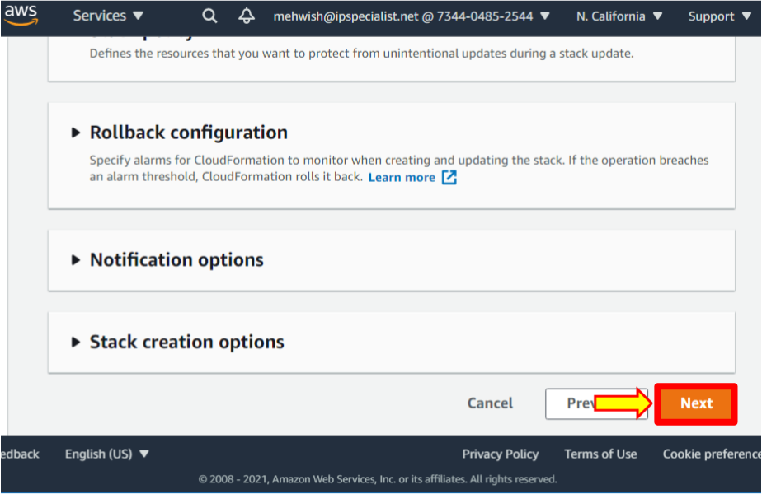

1. Review the stack. Scroll down and click on the **Create stack** button.

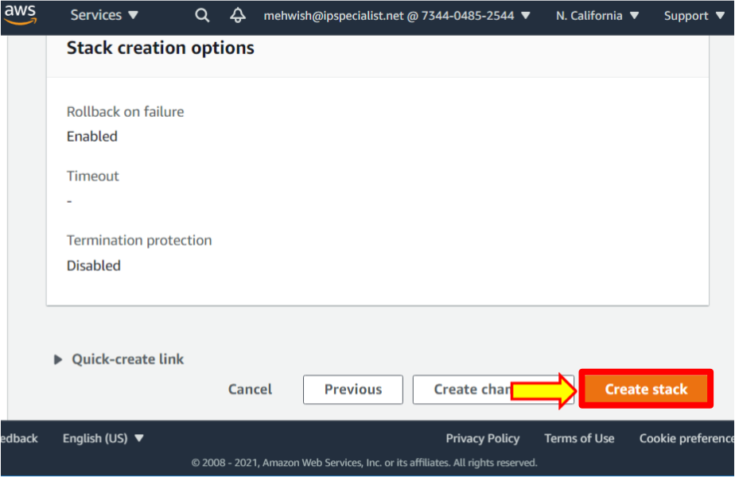

1. Refresh the page to watch the progress.

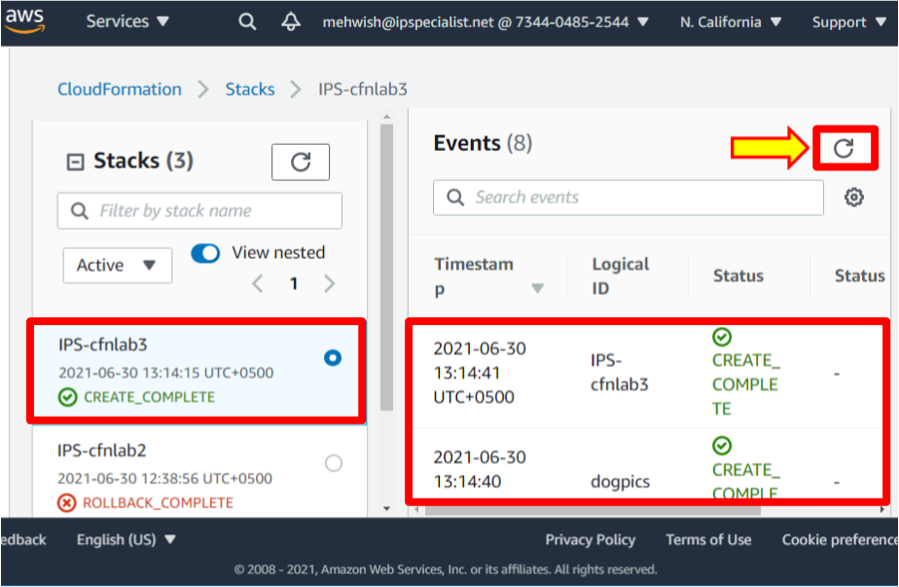

1. Once it is complete, go to the **S3**, where you should see two new buckets: **ips-cfnlab3-catpics-<RANDOM_STRING> and IPS-cfnlab3-dogpics-<RANDOM_STRING>**.

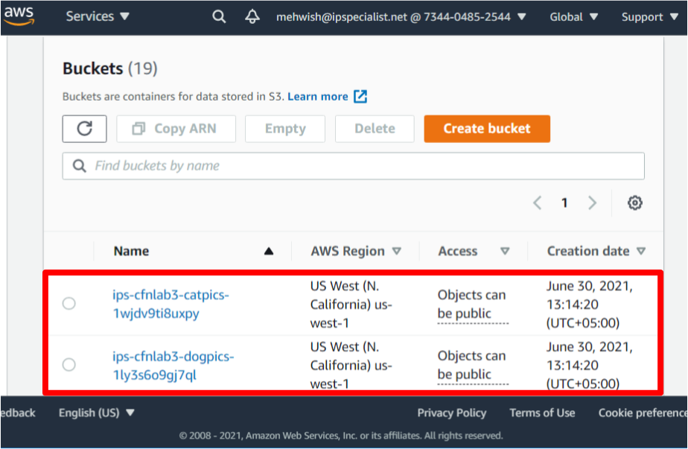

Delete CloudFormation Stacks

1. Navigate to the CloudFormation dashboard by clicking on **Stacks**.

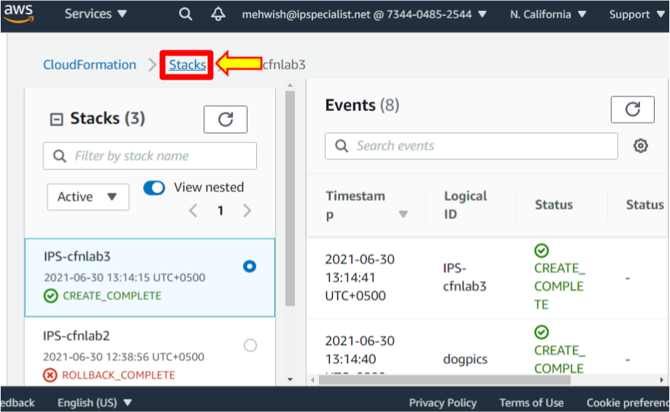

1. Select **IPS-cfnlab**. Then click on the **Delete** button.

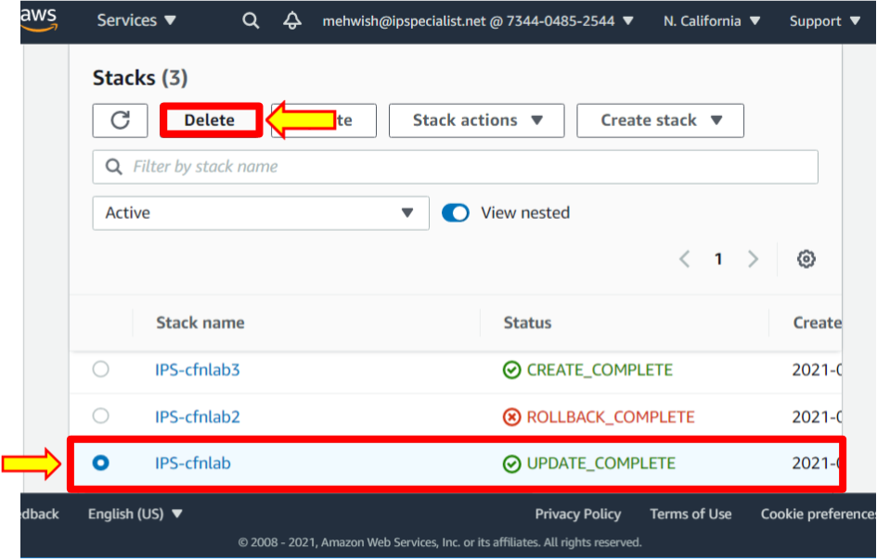

1. In the dialog box, click **Delete stack**.

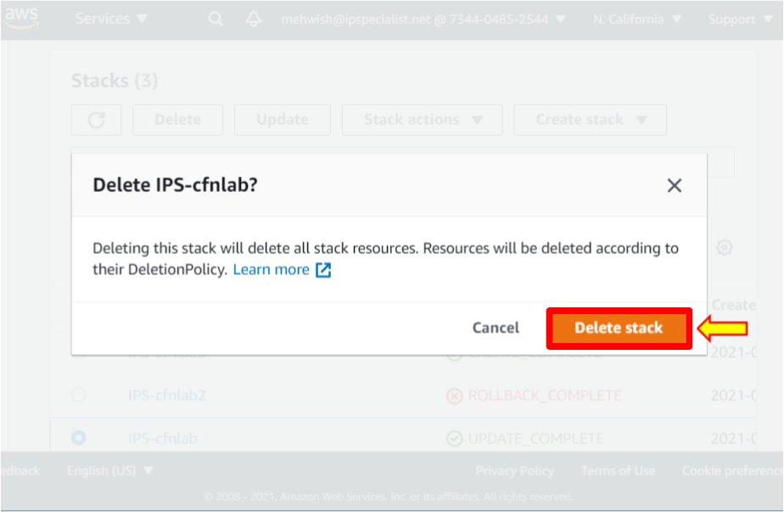

1. Select **IPS-cfnlab2**. Then click on the **Delete** button.

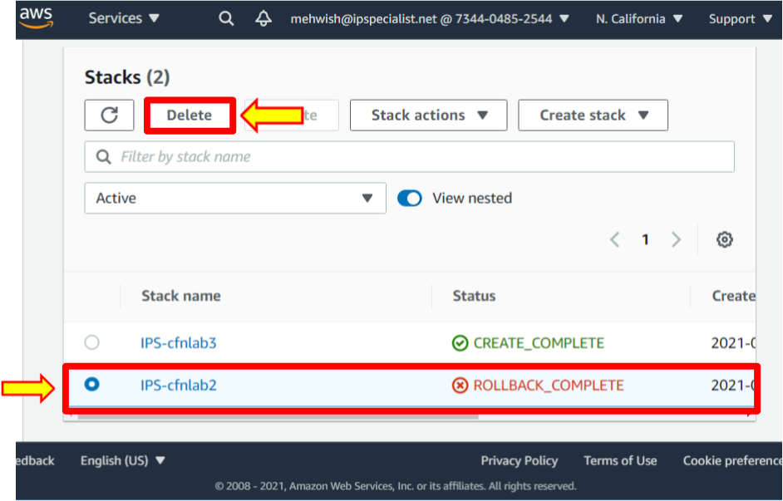

1. In the dialog box, click **Delete stack**.

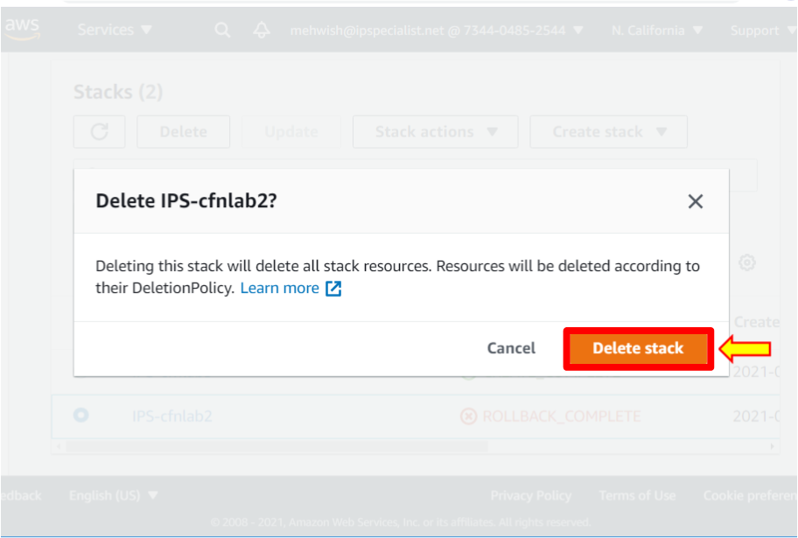

1. Select **IPS-cfnlab3**. Then click on the **Delete** button.

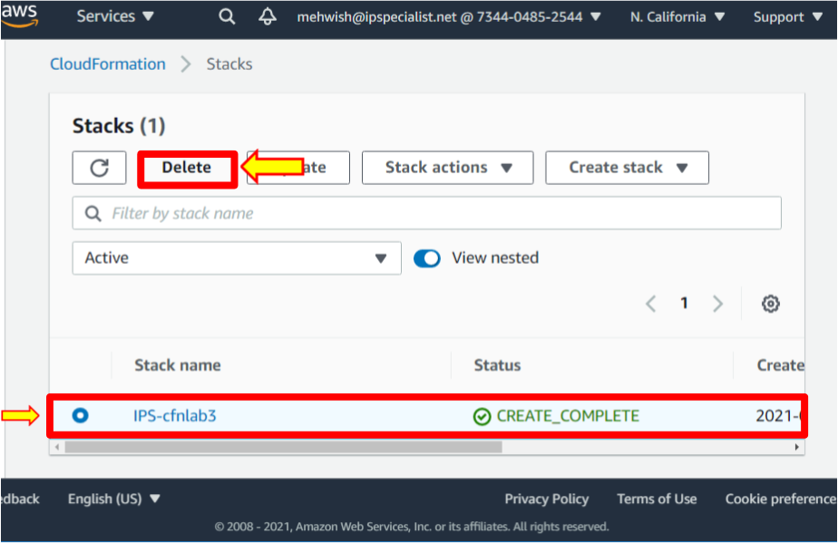

1. In the dialog box, click **Delete stack**.

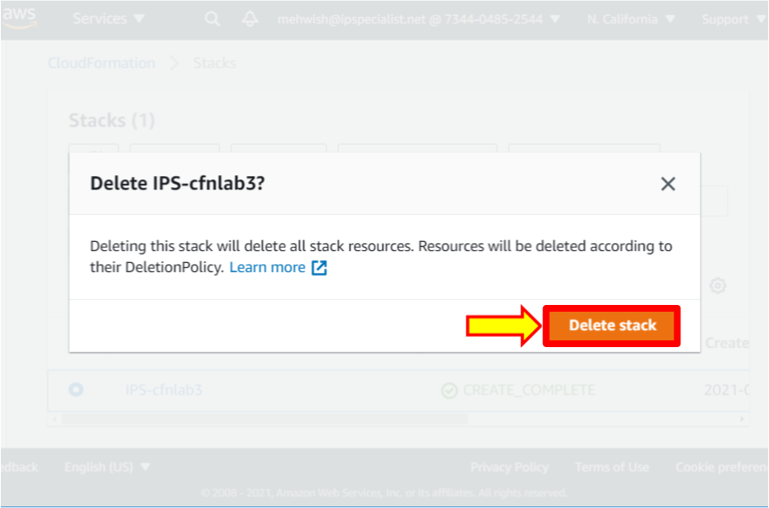

1. The process of deleting **IPS-cnflab3** is in progress.

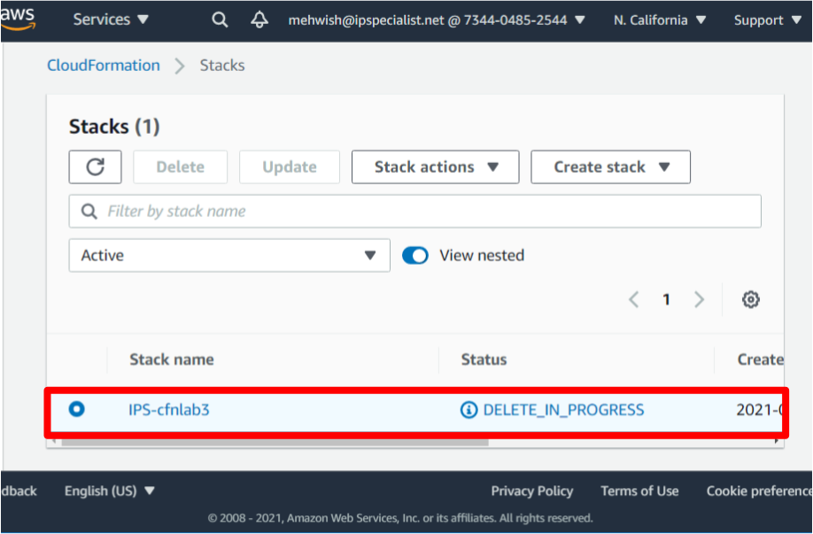

1. Click on the refresh button, and you will see that the **IPS'cfnlab3** stack name has been removed.

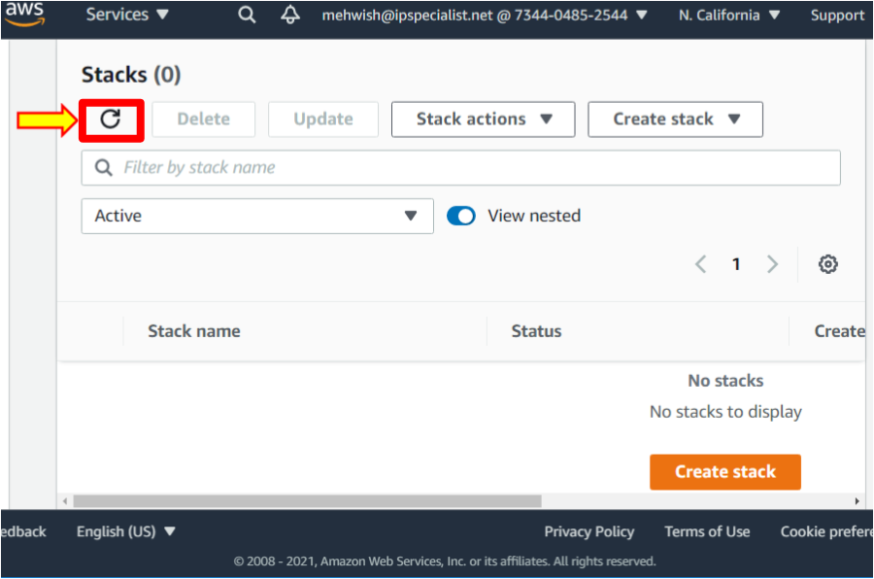

1. Once it is all done, navigate to **S3**. You should see that all the **IPS-cfnlab** buckets are gone, as well as the **catsareawesome** bucket.

